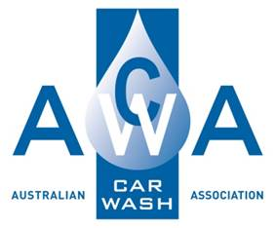

**Safety Handbook**

**Prepared By :**

**15A Higgins Hill Drive**

**Maiden Gully 3551**

**Ph: 0407519351**

**Table of Contents**

Employee Responsibilities 1

Manual Handling 1

Lifting 1

Pulling and Pushing 1

Personal Protective Equipment (PPE) 2

Safe Work Methods and Procedures 2

Hazard Reporting 2

Alcohol and Drug Restrictions 2

Accidents and Incidents 2

Bullying & Harassment 2

Health and Safety Consultation 3

Mobile Phones 3

Equipment Checks 3

Sun Safety 4

First Aid and Infection Control 4

Working Around Vehicles 4

Chemicals 5

Storage 5

Handling of Chemicals 5

Chemical Spills 5

Electrical Safety 5

Housekeeping 6

# Employee Responsibilities

Employees are responsible for ensuring all their work is performed in accordance with the requirements of Health and Safety Act Legislation and Regulations. This includes:

* taking reasonable care for their own health and safety as well as that of others who may be affected by their actions or omissions
* cooperate and comply with any actions undertaken by the employer including use of safety measures and equipment, training information and following safe work processes
* not intentionally or recklessly interfere with or misuse anything provided at the workplace
* involvement in our consultation processes through involvement in Toolbox Meetings as well as informal discussions

# Manual Handling

A high percentage of injuries in all businesses are manual handling related. Many activities and tasks in your work will require manual handling such as:

* placing and retrieving items from work vehicles
* carrying heavy items
* reaching high and low for items that are hard to access
* digging
* operating equipment i.e.. plate compactor

Avoid back problems by lifting in the correct manner. Remember it’s YOUR BACK, so bend your legs, keep your back straight, and keep the load close to the body. Lift only what you can comfortably manage, and always remember to ask for assistance if required.

* Always be certain that each load is within your lifting capacity and will not obstruct your line of vision.
* Check beforehand that your route and lay down area are prepared.
* Ensure good footing and maintain a straight back posture.
* Always bend at the knees – it helps to protect your back.
* Grip the object firmly, using the palms of your hands and the roots of your fingers.
* Lift gradually by straightening the legs.
* Wear gloves if handling objects with sharp or ragged edges.
* When an object requires two or more staff members to handle, one employee should give the signals for lifting and lowering the object in unison.
* If you can’t move it safely, report it to Management so assistance can be organised

## Lifting

* 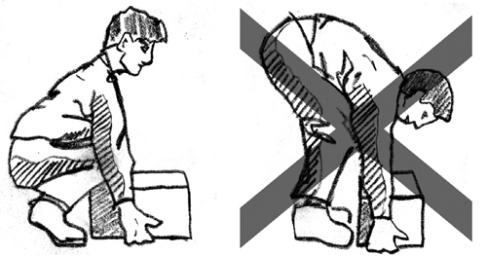Size up load
* Obtain help if necessary
* Correct footing
* Chin in, and back straight
* Good grip
* Use legs

## Pulling and Pushing

* Size up load
* Obtain help if necessary
* Correct footing
* Chin and back straight
* Good grip for pulling, good contact for pushing
* Use legs

Any specific manual handling risks that are associated with work tasks should be reported to your Supervisor verbally or by using the Hazard Report.

# Personal Protective Equipment (PPE)

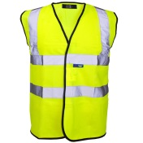Personal protective equipment used by workers should include safety glasses and gloves for working with chemicals, sun protection, ear protection for noisy environments, gloves good quality covered in footwear, high visibility clothing or high visibility vests. Employees are responsible to notify Management of damaged or worn PPE that needs replacing or repair and for its correct storage and care.

# Safe Work Methods and Procedures

Safe Work Methods and Procedures have been developed for all major equipment and work processes. These methods and procedures provide information on safe work processes and the use of personal protective equipment to ensure that work processes are carried out safely and with minimum risk to health. These Safe Work Instructions may not necessarily cover all possible hazards and should be used in conjunction with other training and experience.

# Hazard Reporting

All workers are responsible to be aware of any hazards or safety issues that are present in the workplace. Workers should focus on hazards that may cause injury to themselves, other workers or to customers. Hazards could include damaged equipment, hazards that could cause slips, trips and falls and chemical spills. Hazards should be reported to your Supervisor verbally or on the Hazard Report to enable remedial actions to be taken within an appropriate timeline.

# http://galleryplus.ebayimg.com/ws/web/261225802875_1_0_1/1000x1000.jpgSign Clip ArtAlcohol and Drug Restrictions

If you are affected by alcohol or illegal drugs during work, you may endanger yourself, your fellow staff members, customers, contractors and others. You are not to be in any way affected by drugs or alcohol while at work. Alcohol and illegal drugs must not be brought onto or consumed on our worksites or premises. Any person under or suspected of being under the influence of alcohol or illegal drugs while at work, will face disciplinary action which may include termination of employment.

# Accidents and Incidents

All accidents/incidents which occur during your work must be reported to Management to ensure appropriate documentation and records are completed and to make sure sufficient information is kept for future reference. Management may secure the site of the incident if appropriate. For injuries/incidents that require urgent attention, emergency personnel should be notified immediately to secure the safety of all involved people. Emergency services can be notified by dialling TRIPLE ZERO (000). Workers should follow the direction of emergency service personnel in an emergency situation including providing assistance to emergency services.

# Bullying & Harassment

Bullying and harassment is not an acceptable part of our work culture. Management and employees have a responsibility to behave in a professional manner and to treat each other with dignity and respect when they are at work. Management has a responsibility to ensure employees are not bullied or harassed. Customers, contractors and others in the workplace can also be included in this process. Employees who experience or witness bullying or harassment are encouraged to report it as soon as possible.

Some examples of Bullying and Harassment are:

* [](http://www.google.com.au/url?sa=i&rct=j&q=&esrc=s&frm=1&source=images&cd=&cad=rja&docid=cUrW1SMy2-JeTM&tbnid=CU6C2gGKCWOCfM:&ved=0CAUQjRw&url=http://www.sciencedaily.com/releases/2009/10/091031002319.htm&ei=OgZ7UpynOY7xlAWruoA4&bvm=bv.56146854,d.dGI&psig=AFQjCNHOA7_dyDaDIYizVnj5-ko0p61NOQ&ust=1383880631826800)sabotaging someone’s work and ridiculing someone’s opinions
* isolating an employee from normal work interactions and activities,
* initiation of teasing or regularly making a person the brunt of pranks or practical jokes
* displaying written or pictorial material or sending emails that degrade or offend
* offensive posts on social media i.e.. Facebook, Twitter
* overwork or unnecessary pressure or impossible deadlines
* giving someone the majority of unpleasant tasks
* verbal abuse or humiliating someone
* physical or verbal intimidation
* sexual or other unwanted advances e.g. touching, whistles/ comments, jokes, gestures

It is important employees realize that management actions carried out in a fair way do not constitute bullying or harassment. For example:

* Setting performance goals, standards and deadlines
* Deciding not to select a worker for promotion
* Informing a worker of unsatisfactory work performance
* Informing a worker about inappropriate behaviour

# Health and Safety Consultation

We will consult with workers to provide you with information and get your ideas on managing safety. This may be done in conversations with workers or in Toolbox Meetings.

The Toolbox Meetings will be used to consult staff about health and safety issues, provide health and safety information to staff and provide a forum for discussion of any issues relating to the work site, work processes, training and hazard and risk control.

# Mobile Phones

Mobile phones must never be used if you are involved in a work task. Let incoming calls go through to message bank and return the call later during a break. If it is urgent and you need to use your mobile phone during your work, let your Supervisor know. Move to a non-work/vehicle area where you are safe and cannot be injured.

# Equipment Checks

Workers should be aware of any unusual movements, unusual sounds or other changes in the operation when using equipment. Note should also be taken of correct operation of any safety devices fitted. Any faults should be assessed and use of the equipment must not continue if the hazard is likely to cause a risk to health or safety.

All faults must be reported to Management as soon as possible - immediately if the problem could cause an accident. Equipment should be inspected prior to each time it is used.

# Sun Safety

Skin cancer is a preventable disease and practicing sun protection can prevent many skin cancers. The following control measures should be used to ensure that the risk of damage from the sun is minimised or eliminated:

* 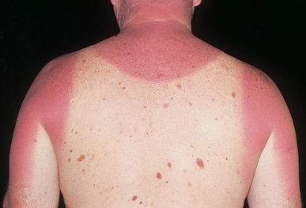Always wear a wide brimmed or legionnaire hat when working in the sun. Tasks that are performed in windy conditions or involve constant movement will require a hat that stays firmly on the head. A tie and toggle on a hat can be used on windy days
* For tasks which require a lot of bending, have a flap on the back of the hat to keep the sun off the back of the neck
* If possible, wear light coloured clothes as they reflect the heat
* Do not wear clothes that allow light through. This means that the UV rays are also getting through to your skin
* When possible, try to perform outdoor tasks in the shade
* Where possible, schedule non-urgent activities to avoid some if not all of the peak ultraviolet period (10am to 3pm)
* Always wear appropriate clothing to cover the skin when working in the sun. If appropriate, wear longer legged shorts and shirts or tops which have longer sleeves and a collar
* If you choose to wear clothing that exposes the skin to the sun, you should regularly (suggest every 2 hours) apply 30+, water resistant sunscreen to all areas of skin exposed. If perspiring freely or working with water, sunscreen must be reapplied more often
* When possible, apply sunscreen onto dry skin at least 15 minutes prior to UV exposure
* Always wear appropriate, wraparound sunglasses that offer 99% UV block out to give maximum protection to the eyes
* Be wary on windy and cloudy days. Ultraviolet rays are scattered in all directions by the cloud and can still burn
* Take extra precaution when working on or near water, concrete, sand and light coloured surfaces as they reflect the UV rays and can inflict a more intense burn

# First Aid and Infection Control

A First Aid kit compliant with the First Aid Code of Practice will be available at all worksites.

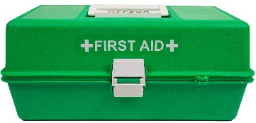If emergency treatment is required, emergency services should be contacted on phone number "000". Situations which are not medical emergencies but require further specialised medical treatment should be referred to a private medical practitioner. An Injury/Accident/Incident Report should be completed for any injuries.

# Working Around Vehicles

Workers should make themselves aware of the traffic areas, direction of travel of vehicles at the site and any hazardous areas e.g. blind corners.

Where possible, avoid carrying out works in traffic areas during busy periods. What for quiet times to carry out the works. When working in or near a traffic movement area, always face the direction of the traffic. Place witch’s hats or other warning devices when working in traffic areas.

# Chemicals

## https://paisleypetroleum.files.wordpress.com/2014/06/20140522_151521_richtonehdr-1.jpgStorage

Chemicals will be stored as recommended in the relevant Material Safety Data Sheets with particular attention paid to segregating chemicals that cannot be stored together. (refer to the MSDS for this information). As a general rule solids will be stored above liquids.

## Handling of Chemicals

Handling of chemicals must be carried out with great care and the following procedures shall be observed:

* Obtain and read the manufacturer’s material safety data sheet (MSDS) for every chemical used and implement recommendations including your knowledge of the chemical use in your workplace.
* Use the minimum amount of any chemical and if there is a choice, use the least toxic or least flammable substances
* Clearly label all containers and include a standard warning label as necessary. Always carry out correct storage and disposal procedures
* Use correct handling methods, protective devices and clothing required for the particular substance as specified on the MSDS
* Minimise your exposure to chemicals by remaining upwind during use and always handle chemicals in a well-ventilated area
* Always use the recommended PPE during use and ensure your PPE is clean and in good condition
* Find out beforehand the correct treatment, in the case of an accident, for the harmful effects of hazardous materials
* Wash hands after handling chemicals
* Food and drink must not be taken into or consumed in an area where chemicals are handled or stored

# Chemical Spills

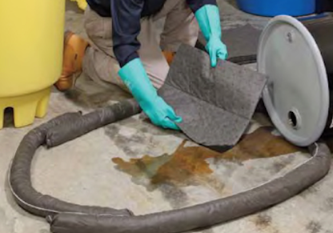Spillage of chemicals should be dealt with immediately. The method employed will depend upon the type of material spilt and the surface on which it has been spilt.

Control the spill to limit the amount of chemical that is spilt. Limit the spread of the spilt chemical using absorbent material. If the spill involves flammable chemicals isolated the area or evacuated if necessary. Specific details on handling chemical spills should be obtained from individual MSDS.

# Electrical Safety

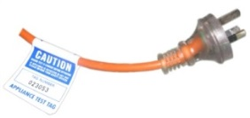Before using any electrical equipment or leads you should always give it an overall inspection including switches, leads and plugs. If there is damage to the equipment you should tag it out of service and report it to your Supervisor or Management. All electrical equipment must have a current test tag on the cord – do not use it if it is out of date. If a safety switch or circuit breaker trips during operation of any electrical equipment, always determine the cause and have it rectified prior to continuing work. No double adaptors are to be used and power boards must never be plugged into another power board. Keep electrical equipment and power leads away from wet areas.

# Housekeeping

Housekeeping is one of the more difficult areas of risk to control in many businesses. It needs to be noted that housekeeping standards are usually a very good indicator of health and safety standards in almost all workplaces. Many injuries are caused by slips and trips e.g. back, arms, hands, head, and from conducting work in cluttered and untidy work areas e.g. cuts, bruises. Correct housekeeping principles will minimise workplace hazards and help you to work safely. Cleaning up and organising your work area must be done regularly, not just at the end of a day or week. Integrating cleanliness, tidiness, systematic storage and effective housekeeping into your daily works can help ensure this is done. Common housekeeping issues are:

* items left in designated walk and work areas that obstruct safe movement around sites
* obstructed fire equipment
* rubbish not picked up or disposed of correctly

Some of the main benefits of good housekeeping are:

* Fewer tripping and slipping accidents in clutter free and spill free work areas
* Decreased fire risk
* Safer use of equipment
* Better access to all areas
* More effective use of space
* Improved productivity (equipment and materials will be easier to find and access)
* Improved workplace morale

Management expects each individual worker to set a good example for other employees, visitors and contractors by maintaining a clean, tidy, well organised and clutter free work environment.

**Notes**

**Notes**

**Notes**