# SWM-14. Robbery/ Violence SWMS

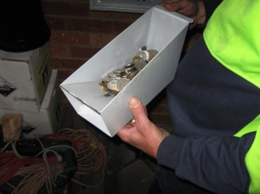**ACWA: Safe Work Method – Robbery/ Violence**

**Note:** This Safe Work Method only provides guidance information and may not necessarily cover all possible hazards and should be used with other references

**Date: August/2023.**

|  |  |
| --- | --- |
| Risk Assessment | |
| **Hazard** | **Risk** |
| Armed and/or violent intruders | * Train staff in competently managing robbery/violence, * Minimise amounts of cash at premises, * Keep major cash handling out of view. |

## Responding to Robbery/Violent Situations

* Always follow instructions – do exactly what the offender says,
* Stay calm and quiet,
* Avoid prolonged eye contact,
* Do not make sudden movements,
* Never argue or yell back at a potential offender,
* Try to keep your hands visible throughout the ordeal,
* Always advise the offender if you are going to move,
* Do not attack the offender,
* If it is safe to do so, take mental notes of the offender’s features e.g., height, hair and eye colour, physical condition, special marks or tattoos,
* Never stare at a person. Prolonged eye contact may be perceived as a challenge or threat,
* If under direct threat or abuse, remove yourself from the situation and seek out your manager or supervisor,
* Do not chase the offender,
* If you have been subjected to a robbery or violent act and are no longer under threat, write down or record all details while they are fresh in your mind.

## Prevention Tips

* Monitor cash levels throughout your shift. Advise your manager or supervisor if cash levels are becoming excessive,
* Don’t be predictable. Collect and count cash at varying times throughout your work,
* Try to handle money at known quiet times when few others are around,
* Count money in the most secure location at your work and away from public view,
* Do not wear jewellery that could be a strangulation or theft hazard,
* Be aware of anyone who appears to be loitering in or around the wash. If they do not leave and you are certain they are suspicious, call the police,
* Park as close to the car wash as possible when arriving at work,
* Avoid poorly lit car parks or streets when travelling to and from work at night or early morning,
* If leaving work in the dark, try to leave with other workers in groups or pairs.