# SWM-04. Cleaning and Working in Wash Bays SWMS

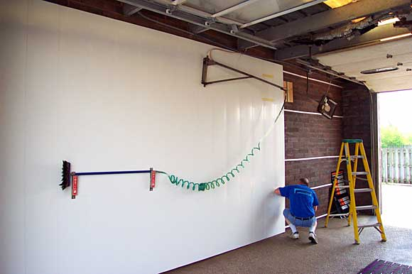**ACWA: Safe Work Method – Cleaning and Working in Wash Bays**

**Note:** This Safe Work Method only provides guidance information and may not necessarily cover all possible hazards and should be used with other references

**Date: August/2023.**

|  |  |
| --- | --- |
| Risk Assessment | |
| **Hazard** | **Risk** |
| Electric cords in wet areas | * Electrocution |
| Slips, trips, and falls | * Injury from falls |
| Contact with vehicles | * Injury from vehicle accident |
| Exposure to chemicals | * Injury or illness from chemical exposure |
| Manual Handling | * Injury lifting |

## Preparation

* Set up an exclusion zone by cordoning off both ends of the bay with witches’ hats or bollards and chains etc, to prevent vehicles from entering your work area,
* If setting up a power cord for your work, ensure the cord is kept well away from other wash bays and wet areas and does not pose a trip hazard to others using the facility,
* Never set up or run a power cord across sharp edges,
* If using electric power tools, keep them clear of moisture and wet areas. Where possible, use cordless power tools,
* Where possible, choose a quiet time (when vehicle traffic is light) for cleaning and maintenance to minimise disruptions to your work.

## Cleaning Pits

* Ensure those not involved in the work task remain clear of the work area,
* Always seek assistance from another worker when removing/replacing heavy grates from pits. Always use a lifting tool to lift while bending,
* Remove and discard sediment from the pre-filter,
* Shovelling from the pit may require an awkward posture. Take regular breaks during this process,
* Be aware that you have an uncovered pit throughout cleaning. Remain as clear of the pit as possible until the grate is replaced, and the pit is covered.

## Cleaning Walls

* Cleaning tiles and walls of bays requires the use of harsh chemicals. Always adhere to the safety recommendations on the MSDS in relation to the chemicals used during cleaning. Use any required PPE, e.g., masks, gloves, safety glasses,
* Pressure spraying will cause the chemicals to aerosol, so it is important to protect exposed skin, the eyes, mouth, and nose,
* Ensure others are kept a safe distance away during the cleaning to avoid contact with any spray drift,
* Avoid using these chemicals on windy days where the spray may drift lengthy distances or to other areas of the wash that may be in use.

## Maintenance Work

* Remember you are working in a wet area. Exercise caution if using electricity,
* If using a ladder to access the work area, take extra care to ensure you don’t slip on ladder rungs,
* Ensure the ladder is positioned correctly and stable to prevent slipping,
* Do not leave the work area unattended if there are hazards exposed.