# SWM-02. Chemical Safety SWMS

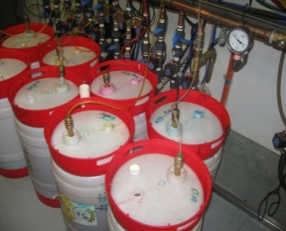**ACWA: Safe Work Method – Car Washing**

**Note:** This Safe Work Method only provides guidance information and may not necessarily cover all possible hazards and should be used with other references.

**Date: August/2023.**

|  |  |
| --- | --- |
| Risk Assessment | |
| **Hazard** | **Risk** |
| Hazardous substance/ Dangerous good | * Injury/illness from contact, inhalation, ingestion, * Burns, * Incorrect use, * Environmental damage, * Injury/illness from incompatibility with other chemicals, * Unlabelled container, * Injury from an explosion |

## Safe Use of Chemicals

* Ensure you have access to the Safety Data Sheets (SDS) for all chemicals used at the workplace,
* Always read the labelling and/or SDS, ensuring you understand the hazards of the chemical,
* Apply the recommended control measures to be used during use, e.g., Personal Protective Equipment (PPE), safety glasses, chemical gloves,
* Always prepare and apply the chemical according to the manufacturer's instructions given on the label or MSDS, taking special note of the rate of application and the safety directions,
* Make sure the chemical is designed for the purpose for which you are using it,
* Always consider the weather conditions before using the chemical, e.g., Windy days can cause chemicals to spread and become unnecessarily airborne,
* Never decant chemicals into an unsuitable or unlabelled container,
* Never smoke, eat or drink during chemical use. Always wait until you have finished using the chemical, and only after you have washed your hands and any exposed skin areas,
* Never expose flammable substances to ignition sources,
* Be particularly careful when using chemicals near waterways or stormwater drains,
* Use recognised spill containment methods to prevent the chemical from entering waterways or stormwater drains, e.g., absorbent, bunding,
* Dispose of any spilled substances in compliance with EPA regulations,
* Always dispose of empty containers so they pose no threat to humans, animals, or wildlife,
* Always store chemicals according to the manufacturer’s instructions and/or SDS ensuring compatibility with other chemicals,
* Transport chemicals in a secure, upright position to prevent any spillage,
* If symptoms of illness occur during or shortly after using a chemical, depending on the severity, contact a physician or go to the hospital. Take the label or SDS from the chemical with you,
* Report any chemical spills or incidents to management.