Safe Work Method – Electrical Safety
Safe Work Method – Electrical Safety
Note: This Safe Work Method provides guidance information only and may not necessarily cover all possible hazards and should be used in conjunction with other references. | 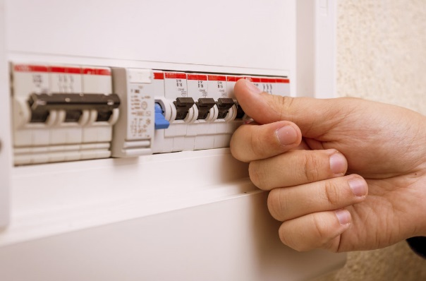

- When using electrical equipment, always check that the power cord has a current electrical test tag. Do not proceed if the next test date has expired or if there is no tag attached,
- Always access power through an outlet protected by an Residual Current Device (RCD) or portable RCD ensuring there is a current test and tag sticker next to it,
- Always give the electrical equipment a thorough inspection prior to use. Do not proceed if faults or damage is detected,
- Remain alert for cords that become worn or damaged. Remember they are sometimes dragged around on concrete or the ground and over sharp edges,
- Regularly inspect switches on electrical equipment. Tag equipment out of use if faults are found,
- If a safety switch/RCD trips during operation of any electrical equipment, always determine the cause and have it rectified prior to continuing work,
- Do not use electrical equipment where it may come into contact with water,
- If using power equipment outside, ensure leads and plugs cannot come into contact with water,
- Where possible use battery or cordless power tools rather than mains powered tools,
- Avoid having electrical cords across walkways, particularly if sharing the worksite with others,
- Remain aware of the location of power cords when using electrical equipment to avoid entanglement and/or trips,
- Keep power cords and leads out of the immediate workspace to prevent them being damaged eg. cut, burnt,
- When unplugging cords from power outlets always turn off the power point first and grip the plug, NOT the cord,
- Do Not use double adaptors as they can become partially unplugged and expose live conductors or cause micro arcing which can result in fires,
- Do Not plug one power board into another power board as it can lead to overloading the circuit and cause a fire,
- Always ensure your hands are dry whenever handling electrical equipment including switching off power points.

