# \\Eastmen-d32cceb\el server\Active Files\CurrentBusinesses\Immediate Businesses\Beechworth Bakery\Beechworth Bakery - Bendigo\Bendigo Photos\Photo 054.jpgSWM-11. Office Ergonomics and Computer Workstation Setup SWMS

## ACWA: Safe Work Method – Office Ergonomics and Computer Workstation Setup

**Note:** This Safe Work Method only provides guidance information and may not necessarily cover all possible hazards and should be used with other references

**Date: August/2023.**

|  |  |
| --- | --- |
| Risk Assessment | |
| **Hazard** | **Risk** |
| Manual handling | * Musculoskeletal injury |
| Electrical | * Electrocution |
| Slips and trips | * Injury from fall |
| Eye strain | * Eye damage |
| Hazardous posture | * Musculoskeletal injury |
| Repetitive keyboard/mouse use | * Carpal tunnel syndrome |

# Workstation Organisation

## Working Postures

* When sitting in the normal working position, your head and neck should be upright or in line with the torso (**see image 1. Computer Workstation Setup**),
* Your head, neck and trunk should face directly forward,
* Your body should be perpendicular to the floor (you may lean into the backrest but not forward),
* Your upper arms and elbows should be close to the body, not extended outward,
* Forearms, wrists and hands should be approximately 90 degrees to the upper arm,
* Your thighs should be parallel to the floor, and your lower legs should be directly up and down. You may need to implement the use of a footrest to achieve this. Ensure thighs have sufficient clearance space from the top of the desk,
* Ensure your legs and feet have enough space under the desk to take up the correct position. Keep electrical equipment contained and clear of the main work area,

## Seating

* The backrest should provide support for your lower back whilst working at the workstation,
* The seat pan should be wide enough to accommodate the specific user and should not press into the back of your knees or hamstrings,
* Armrests, if used, should support both forearms evenly while you perform computer tasks and not interfere with movement,
* Only fully adjustable chairs with five legs, adjustable height, seat pan tilt and backrest should be used for staff performing continual workstation tasks,

## Keyboard and Mouse

* The mouse should be located close to the keyboard to prevent overreaching,
* The mouse should be easy to activate and fit the size and shape of your hand,
* Your wrists and hands should rest on a suitable surface with no sharp or hard edges,
* For staff consistently using the keyboard, the desktop should support both arms evenly.

## Monitor

* The top of the screen should be at or below eye level so you can read it without bending your head or neck down or back (adjustments may need to be made for users with bifocals),
* The monitor should be located at a distance to allow you to read the screen without leaning your head, neck or body forward or backward and should be directly in front of you (not to one side),
* Always position the monitor to prevent glare on your screen. This can cause you to assume an awkward posture to clearly see information on the screen.

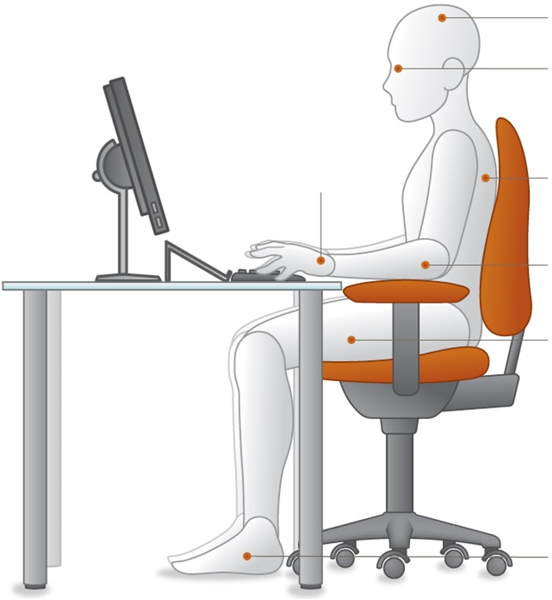

Head upright and over your shoulders.

Eyes looking slightly downward without bending from the neck.

Back should be supported by the backrest of the chair that promotes the natural curve of the lower back

Elbows bent at 90˚ with forearms horizontal. Shoulders should be in line with hips and relaxed but not slumped.

Thighs basically parallel to floor with knees slightly lower than hips. Front of seat pan does not put pressure on back of thighs or knees

Feet fully supported and flat on the floor. If this isn’t possible, then the feet should be fully supported by a footrest

**Image 1. Computer Workstation setup.**

## Workstation Accessories

* If regularly keying data from hard copy sheets, implement the use of a document holder,
* Document holder should be at about the same height and distance as the monitor screen so there is minimal head movement or need to refocus,
* Keep frequently used items within reach to prevent constant reaching, e.g., biros, stapler, hole punch,
* Locate the telephone within reach and on the correct side to allow writing or other tasks at the same time,
* If answering the telephone constantly, you need to implement the use of a headset to allow the use of both hands,
* If possible, locate the printer away from the main workstation to avoid cluttering the immediate area. This will also allow you to stand up and move regularly, avoiding muscle stiffness and soreness,
* If working at a laptop, ensure the laptop is raised to the correct height as detailed above and use a standard keyboard and mouse in place of the laptop keyboard and mouse,
* Ensure the floor area around and under your workstation is free of cords, boxes, files and rubbish to eliminate the need for awkward posture,
* **Even with an ideal sitting posture, you must change your posture and position frequently by adjusting the setting on the chair and alternating tasks (typing, writing, walking, and standing) as often as possible. This will ensure proper blood flow and reduce the risk of injury.**

## General Office Safety

* Locate under desk drawers away from the main entry/exit path to the workstation,
* Plug-in electrical equipment to prevent cords laying across walkways,
* Use tape or ties to confine cords and leads away from walkways and leg spaces
* Where possible, locate filing cabinets to open parallel with a wall and not into walkways or doorways,
* Be aware not to overload the top drawer of filing cabinets as they may tip,
* Ensure airflow from air conditioning or fans is directed away from you,
* When possible, plan your day to prevent continual computer work. Vary tasks to avoid muscle stiffness/soreness,
* Regularly check all office equipment and accessories. Report damage or faults to Car Wash Management.