# SWMS-06. Fire Extinguisher Use SWMS

|  |  |
| --- | --- |
| ACWA | |
| Safe Work Method – Fire Extinguisher Use **Note:** This Safe Work Method provides guidance information only and may not necessarily cover all possible hazards and should be used in conjunction with other references.  Date: August/2023 |  |

|  |  |
| --- | --- |
| Risk Assessment | |
| Inability to use extinguisher | * Burns * Injury/Illness from fire |
| Incorrect extinguisher type | * Burns * Electrocution |
| Toxic gases | * Injury/illness from inhalation of gases |
| Falling/flying debris/objects | * Injury from contact with debris/objects |

# Preparation

* Familiarise yourself with the different types of fire extinguishers at the workplace,
* Ensure you take the time to understand which extinguishers are suitable for different types of fires. It is also important you identify which extinguishers can’t be used on certain fires. E.g., Electrical fires

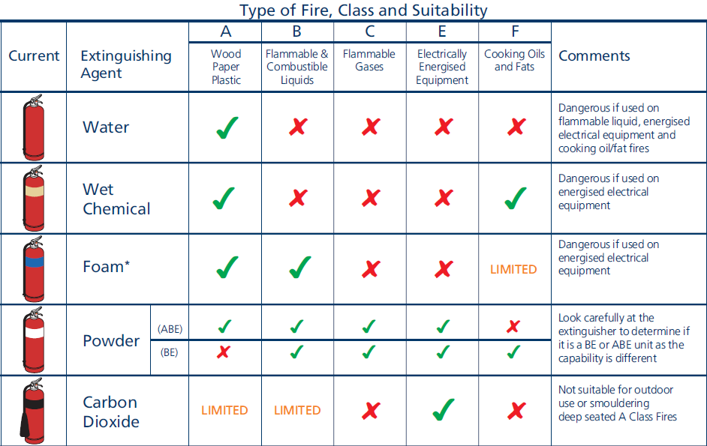

* Familiarise yourself with the operation of all fire extinguishers including pin removal and handle operation,
* Be aware of the locations of all the fire extinguishers throughout the premises and/or at worksites.

|  |
| --- |
| In the case of fire, use the emergency information sheet at your telephone to CALL YOUR LOCAL FIRE BRIGADE |

# Selection of Fire Extinguisher

* Try to determine the type of material that has caused the fire. E.g., Is electrical equipment involved,
* Select the appropriate fire extinguisher for the type of fire,
* If in doubt as to the cause of the fire, use the dry foam extinguisher with the white band. It is suitable for almost all fires,
* NEVER use a water extinguisher on an electrical or flammable liquid fire,
* If you have a choice of extinguisher size, be sure to select an extinguisher of sufficient volume to complete the task.

# Extinguishing Fire

* Do not attempt to extinguish a fire that is clearly too large for the equipment at the premises. ALWAYS call your local Fire Brigade,
* DO NOT enter areas if there is a risk of being overcome by smoke or hazardous gases,
* Prior to attacking fire, release pin from handle and briefly squeeze to ensure extinguisher will operate correctly. Hold hose at this time,
* Take up a position at a safe distance that will allow you access to the base of the fire,
* Squeeze handle and aim hose at the base of the fire,
* Use a sweeping motion to extinguish fire remembering to aim at base of fire. This is where the fuel is,
* Once fire is being contained move forward to complete extinguishing process,
* To successfully overhaul the fire, ensure that every piece of burning material is completely extinguished,
* Never position yourself in an area where you may be burnt or come in contact with falling or flying debris or hazardous materials ejected from the fire,
* If fire proves more difficult to extinguish than initially thought, evacuate the building and close all doors to suppress the spread of the fire. Wait for the arrival of the Fire Brigade.

# Maintenance

* After fire, ring your fire safety professional to replenish fire extinguisher stocks,
* Use your fire safety professional to check and stamp all fire extinguishers on a six-mo­nthly basis.