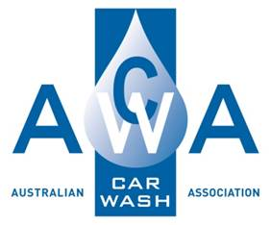

**Environmental Management Procedure**

**Prepared By :**

**15A Higgins Hill Drive**

**Maiden Gully 3551**

**Ph: 0407519351**

**Contents**

Environmental Management Procedure 1

Purpose: 1

Scope: 1

Procedure: 1

# Environmental Management Procedure

## Purpose:

To review the environmental aspects of the business operation of Car Wash and identify and control all risks to eliminate or minimise any adverse environmental impacts.

## Scope:

This procedure applies to all operations and activities carried out at the Car Wash.

## Procedure:

| Process | Methodology | Documentation |
| --- | --- | --- |
| Risk identification | Identify the specific environmental risk areas present at the Car Wash.  These could include:   * chemical spills. * water recycling. * pit cleaning. * waste disposal. | * Visual check |
| Environmental hazards must be reported to Management as soon as possible to minimise the environmental impact. | * Work Diary notes |
| Controls | Chemical spills will be cleaned up immediately with care taken to avoid chemicals entering stormwater drains or waterways as necessary. | * Work Diary notes |
| Materials for chemical spill cleanup should be on hand and include:   * buckets or heavy plastic bags. * Shovel. * absorbent material eg. Zeolite. |  |
| Water recycling and treatment protocols will be followed to ensure the water is recycled to appropriate standards before being used. | * Work Diary notes |
| Pits will be cleaned regularly to avoid overflow of waste material into stormwater drains or waterways. | * Work Diary notes * Receipts |
| Waste Disposal | All work site excess and waste material will be disposed of according to local government and Environmental Protection Agency requirements. | * Waste Disposal dockets |
| Reporting | Environmental accidents or incidents will be initially reported to Car Wash Management, recorded and reported to the State EPA if significant. | * Accident/Incident Report form |