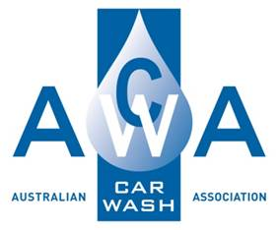

**Contractor Management Procedure**

**Prepared By :**

**15A Higgins Hill Drive**

**Maiden Gully 3551**

**Ph: 0407519351**

**Contents**

Contractor Management Procedure 1

Purpose: 1

Scope: 1

Procedure: 1

# Contractor Management Procedure

## Purpose:

The purpose of this procedure is to ensure that all contractors understand:

* their obligations in relation to maintaining a healthy and safe workplace during their work at the Car Wash and to have appropriate insurances in place.
* the work environment related to the project, so they work as safely as possible and to ensure health, safety and environmental issues are known and addressed.

## Scope:

This procedure applies to all contractors engaged to work for the Car Wash.

## Procedure:

| Process | Methodology | Documentation |
| --- | --- | --- |
| Assessment and Induction | Contractors will be assessed as to their ability to comply with health and safety and allied legislation. This form should be mailed out to contractors (with an explanatory letter) and returned prior to them commencing work | * Contractor Health and Safety Assessment |
|  | Contractors will be required to complete the Health and Safety Assessment annually to coincide with the payment of their public liability insurance premium | * Contractor Health and Safety Assessment |
| Risk Management | For hazardous tasks that are complex, unusual tasks or that require strategic planning and preparation, contractors may be required to complete a Safe Work Method Statement for these works in conjunction with Car Wash Management e.g., digging up driveways | * Safe Work Method Statement |
| Consultation and Reporting | Contractors will be consulted in relation to any health and safety issues related to their work. Risks will be controlled to ensure work can proceed safely e.g., using barriers to isolate work areas from the public. | * Safe Work Method Statement |
|  | Contractors will notify the car wash management of any accidents or incidents in relation to their contracted work | * Accident/Incident Report |