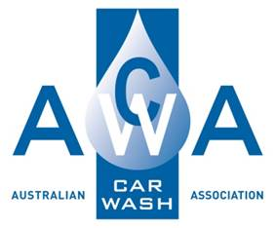

**Manual Handling Procedure**

**Prepared By :**

**15A Higgins Hill Drive**

**Maiden Gully 3551**

**Ph: 0407519351**

**Contents**

Manual Handling Procedure 1

Purpose: 1

Scope: 1

Definition: 1

Procedure: 1

# Manual Handling Procedure

## Purpose:

The purpose of this procedure is to ensure the identification, assessment and control of all manual-handling tasks performed by Car Wash staff, in accordance with the requirements of Health and Safety legislation and regulations.

## Scope:

This procedure applies to all work tasks involving manual handling and is designed to assist employees be protected from the risk of injury due to exposure to manual handling hazards.

## Definition:

Manual Handling means any activity requiring the use of force exerted by a person to lift, lower, push, pull, carry or otherwise move, hold or restrain any animate or inanimate object.

## Procedure:

|  |  |  |
| --- | --- | --- |
| Process | Methodology | Documentation |
| Hazard Identification | The workplace will be constantly monitored for manual handling hazards particularly when there are changes such as new equipment or work practices. | * Hazard Report Form. |
| Risk Assessment | Work processes identified as being hazardous or involve high risk movement should have a Manual Handling Risk Assessment completed if the risk cannot be easily or effectively controlled. | * Manual Handling Risk Assessment. |
| Risk Control | Effective risk controls need to be introduced to reduce the risk of injury by eliminating the risks and where that is not practicable, to reduce the level of risk as far as practicable eg. lifting equipment, trolleys, lifting in pairs, lifting bars for grates. | * Manual Handling Risk Assessment. |
|  | Risk controls need to be constantly monitored to ensure ongoing effectiveness. | * Hazard Report Form. * Health and Safety Meeting Record. |
| Consultation | Workers will be consulted in relation to identifying and controlling manual handling risks and monitoring the effectiveness of these controls. | * Hazard Report Form. * Manual Handling Risk Assessment. |