# SWM-16. Working in Adverse Weather SWMS

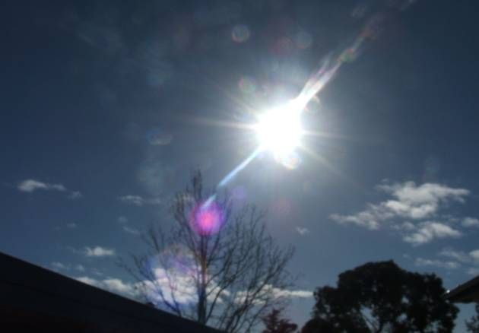**ACWA: Safe Work Method – Working in Adverse Weather**

**Note:** This Safe Work Method only provides guidance information and may not necessarily cover all possible hazards and should be used with other references

**Date: August/2023.**

|  |  |
| --- | --- |
| Risk Assessment | |
| **Hazard** | **Risk** |
| Working in the sun | * Injury/illness from overexposure to sun |
| Working in the cold | * Hypothermia |

## Sun Safety, Heat Stress & Fatigue

* Dress appropriately for the heat or sun conditions,
* Where possible, schedule outside activities to avoid some, if not all, of the peak ultraviolet period (10 am to 3 pm),
* Always wear an appropriate hat when working in the sun,
* For tasks that require a lot of bending, have a flap on the back of the hat to keep the sun off the back of the neck,
* If possible, wear light-coloured clothes as they reflect the heat,
* Do not wear clothes that allow light through. This means that the UV rays are also getting through to your skin,
* When possible, try to perform outdoor tasks in the shade,
* Always wear appropriate clothing to cover the skin when working in the sun. If appropriate, wear longer-legged shorts and shirts or tops that have longer sleeves and a collar,
* If you choose to wear clothing that exposes the skin to the sun, you should regularly (suggest every 2 hours) apply 30+ water-resistant sunscreen to all areas of skin exposed. If perspiring freely or working with water, sunscreen must be reapplied more often,
* When possible, apply sunscreen onto dry skin at least 15 minutes prior to UV exposure,
* Always wear appropriate, wraparound sunglasses that offer 99% UV block out to give maximum protection to the eyes,
* Be wary on windy and cloudy days. Ultraviolet rays are scattered in all directions by the cloud and can still burn,
* Take extra precaution when working on or near water, concrete, sand and light-coloured surfaces as they reflect the UV rays and can inflict a more intense burn,
* Remember to drink sufficient water to prevent dehydration and fatigue during your work on hot and/or humid days,
* Take regular breaks on hot or humid days to prevent work/heat stress and the possibility of fatigue,
* Remain alert to the initial signs of heat stress/fatigue, e.g., dizziness nausea.

## Working in Cold/Inclement Weather

* Dress appropriately for the cold, windy or wet conditions,
* Ensure you are wearing sufficient warm clothing on cold days,
* Always wear good quality socks and footwear, as it is important to keep the feet warm to prevent slips, trips and stumbles,
* If necessary, wear good quality thermal clothing to prevent body parts from exposure to severe cold and the possible onset of hypothermia,
* Wear gloves if operating equipment or machinery to keep the hands and fingers warm as required. This may prevent a potential accident from the incorrect or clumsy operation of the controls,
* Never run or rush on cold, wet or frosty days. Be particularly careful as you move around the site to prevent slips, trips and falls. Exercise extra caution if climbing equipment, e.g., ladders,
* Always have good quality, waterproof clothing on hand to use as required.