# SWM-15. Trailer Connecting SWMS

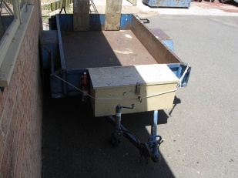**ACWA: Safe Work Method – Trailer Connecting/Disconnecting**

**Note:** This Safe Work Method only provides guidance information and may not necessarily cover all possible hazards and should be used with other references

**Date: August/2023.**

|  |  |
| --- | --- |
| Risk Assessment | |
| **Hazard** | **Risk** |
| Moving equipment/vehicles | * Injury from contact with moving equipment/vehicles |
| Pinch points | * Crushing injury |

## Connecting

* Perform a visual check to ensure no people are between the trailer and the vehicle,
* Reverse with caution at a slow speed,
* Exit the vehicle and check alignment and height in preparation for connection. Align the ball pull with the coupling on the trailer pull. If necessary, use the jockey wheel to adjust the height of the trailer pull,
* Ensure the ball is the correct size to suit the trailer pull,
* Slowly reverse the vehicle until the ball and coupling are closely aligned. Use the parking brake to secure the vehicle in position. Seek assistance when precisely aligning the ball and coupling, particularly if the jockey wheel is difficult to manoeuvre. If applicable, adjust wheel chocks to allow sufficient movement,
* Use the jockey wheel to lower the coupling onto the ball. Keep hands and fingers clear as coupling connects with the ball,
* Ensure the ball, coupling and safety chains are secured, including safety latch,
* Connect the electric system and brakes if applicable. Complete a visual check that the lights are functioning correctly.

## Disconnecting

* Position the trailer in preparation for unhooking. Take care if reversing to ensure no people are behind the vehicle and trailer,
* Position the trailer in a suitable area. Ensure the ground is flat or level to prevent the trailer from moving. Use wheel chocks when necessary,
* Release safety latch and chains in preparation for uncoupling,
* Wind down the jockey wheel to take the weight of the trailer. Continue winding until the coupling lifts clear of the ball. Be aware that the trailer may move during this process,
* Disconnect electric systems and brakes if appropriate,
* All equipment, including couplings, wheels, air, hydraulic and electric systems, should be periodically serviced and inspected by a suitably experienced person.

## Report Faults

* Tag Out trailer from service if faulty, so it cannot be used until fixed.