# SWM-13. Power Tools SWMS

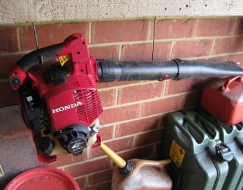**ACWA: Safe Work Method – Power Tools**

**Note:** This Safe Work Method only provides guidance information and may not necessarily cover all possible hazards and should be used with other references

**Date: August/2023.**

|  |  |
| --- | --- |
| Risk Assessment | |
| **Hazard** | **Risk** |
| Moving components | * Cutting * Injury from contact with tool |
| Flying particles/objects | * Contact with particles/objects |
| Electrical | * Electrocution |
| Manual handling | * Musculoskeletal injury |

## Pre-Check

* Check that the power cord has a current electrical test tag,
* Ensure power is directed through an ELCB/RCD at the meter box or power outlet,
* If the ELCB/RCD trips during power tool operation, always determine the cause and have it rectified prior to continuing work,
* Inspect the tool for frayed cords, loose or broken switches, and other obvious problems. Tools that fail this inspection must not be used,
* Check that any guarding is securely in place,
* Do not use power tools in locations where they may become damp or wet,
* When necessary, wear appropriate gloves, footwear and eye and ear protection while using the tool. Do not wear loose clothing or jewellery that may become entangled when operating tools. Tie long hair back.

## Operation

* Avoid accidental starting. Do not hold a finger on the switch button while carrying a plugged-in tool,
* If applicable, ensure you are familiar with the location of the on/off and emergency stop buttons and that they are working correctly,
* Work areas should have adequate lighting and be free of clutter,
* Ensure observers remain a safe distance away from the work area,
* Always stand firmly on the floor/ground and avoid any awkward postures that may cause overbalancing,
* Make sure the immediate work area is clear of other tools, off-cut materials or shavings that have the potential to be slipping and tripping hazards,
* Ensure power cords are well clear of the main works area to prevent accidental contact during the work process,
* Allow the tool to obtain maximum speed before beginning the task,
* Do not place any body parts, particularly your hands, near any moving parts of the tool during operation,
* Never leave the power tool running unattended,
* Never use power tools around flammable liquids and gases,
* Always be aware of any unusual movements, sounds, or other changes during operation. Cease operation if deemed to be faulty or hazardous,
* Ensure power tools are sufficiently cooled prior to any maintenance,
* Disconnect power tools from the power outlet while servicing or storing,
* Do not wrap the cord around the tool for storage,
* Store tools in a dry place.

## Report Faults

* Tag Power Tool if faulty so it cannot be used until fixed.