# SWM-12. Power Blower SWMS

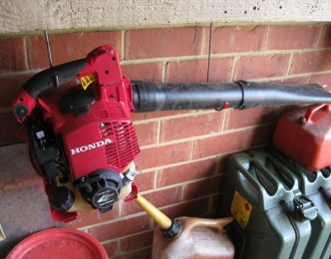**ACWA: Safe Work Method – Power Blower**

**Note:** This Safe Work Method only provides guidance information and may not necessarily cover all possible hazards and should be used with other references

**Date: August/2023.**

|  |  |
| --- | --- |
| Risk Assessment | |
| **Hazard** | **Risk** |
| Manual handling | * Musculoskeletal injury |
| Refuelling | * Burns |
| Moving equipment | * Injury from contact with moving equipment |
| Slips and trips | * Injury from fall |
| Noise | * Hearing deterioration |

## Pre-Check

* Check the blower for loose or missing nuts, bolts, and screws. Tighten and/or replace as needed,
* Ensure any guards are fitted and secure,
* Wear appropriate protective equipment, including safety glasses, hearing protection and close-fitting protective clothing.

## Operation

* Only use a blower if the area is clear. Never direct blower in the direction of other people,
* Do not stand on slippery, uneven or unstable surfaces,
* If using a blower in dusty areas, wear a respirator as required,
* Watch for flying sand and other debris. Be aware of wind direction and try to work upwind, if possible,
* Prior to any maintenance, ensure the engine has cooled sufficiently,
* Never refuel a hot or running motor.

## Report Faults

* Tag Power Blower if faulty so it cannot be used until fixed.