# SWM-10. Manual Handling SWMS

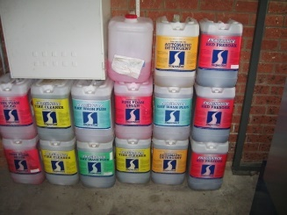**ACWA: Safe Work Method – Manual Handling**

**Note:** This Safe Work Method only provides guidance information and may not necessarily cover all possible hazards and should be used with other references

**Date: August/2023.**

|  |  |
| --- | --- |
| Risk Assessment | |
| **Hazard** | **Risk** |
| Lifting/lowering, pushing/ pulling, dragging, holding, supporting, restraining | * Musculoskeletal injury |
| Repetitive hazardous movement | * Musculoskeletal injury |

## Preparation and Undertaking of Task

* Always use mechanical aids that have been provided for awkward or difficult manual handling tasks (e.g. trolleys),
* Always seek assistance from other workers if you need more clarification about your ability to lift, pull, lower, push, drag or carry an object. Carefully test and inspect the load,
* Plan the lift and ensure the likely route is unobstructed. Be aware of tools, hoses and cords that may be on the floor/ground or uneven surfaces that may cause you to become unsteady,
* Stand as close to the object as you can,
* Bend the knees and keep the back as straight as possible,
* Use your leg and buttock muscles when lifting to reduce the strain on your back,
* Hold the object as close to the body as you can. Try to keep the centre of the weight no more than 20 centimetres from your body,
* Never twist your body during a lift. Turn using your feet, not the torso,
* Never lift and/or carry an unbalanced load,
* Avoid lifting heavy objects directly following a sustained period of sitting or resting,
* Avoid lifting when your feet are too close together. Try to keep your feet spread to at least shoulder width,
* Never stand on an unstable surface that may cause you to slip, trip and/or fall,
* Plan with others to have objects that will need lifting later to be placed at a suitable height,
* Where possible, break the load into smaller parts,
* If involved in a repetitive task, take regular breaks and, if deemed necessary, perform exercises to relieve muscle tension,
* If involved in repetitive tasks for extended periods, swap or rotate jobs to avoid repetitive strain injuries,
* Seek assistance when pushing or pulling heavy or hard-to-move trolleys, particularly over rough surfaces or up a gradient,
* Exercise extra caution during extreme environmental conditions (e.g., wet, or hot weather). This can lead to slips and falls or fatigue,
* NEVER undertake any manual handling operation that is beyond your capabilities. ALWAYS seek assistance.