# SWM-01. Car Washing SWMS

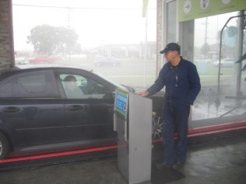**ACWA: Safe Work Method – Car Washing**

Note: This Safe Work Method only provides guidance information and may not necessarily cover all possible hazards and should be used with other references.

**Date: August/2023.**

|  |  |
| --- | --- |
| Risk Assessment | |
| **Hazard** | **Risk** |
| Moving components of equipment | * Injury from contact with moving parts |
| Manual handling | * Musculoskeletal injury |
| Electrical | * Electrocution |
| Moving equipment/vehicles | * Injury from contact with moving equipment/vehicles |
| Slips and trips | * Injury from fall |
| Recycled water spray | * Illness from inhaling water |

## Working Around Cars

* Wear high visibility clothing/vest to ensure you are always conspicuous,
* Wear nonslip shoes to prevent slips,
* Make yourself aware of traffic flow and direction around the car wash,
* Stand to the side of vehicles as they approach,
* Avoid standing between vehicles or between vehicles and other objects,
* If spraying prewash on cars prior to them entering automatic car washes, wait for the car to stop. Avoid standing directly in front of the car or between the car and other approaching cars,
* Avoid walking in front of or between moving vehicles,
* Make eye contact with the driver or alert the driver before stepping in front of a car.

## Hand Washing

* Only designated drivers should drive or move vehicles in the Car Wash
* Driver should be aware of the location of all workers in the immediate area when moving cars. They must ensure all workers are clear of the vehicle before moving it.
* To avoid collisions, be aware of all other vehicle movements as you move vehicles.
* Workers should stand clear of the front and rear of vehicles when they are being moved.
* Wait until the vehicle is stationary, switching off with the gear engaged and hand brake on before beginning to wash or clean.
* Ensure you have firm footing when reaching to wash the top of vehicles, e.g., standing on wheels to wash the roof of 4WD vehicles.
* Keep electrical cords and equipment clear of water or wet areas
* Keep cords and hoses clear of walk areas to avoid trips
* Minimise awkward postures when cleaning cars. If necessary, change jobs/tasks to provide a break from awkward jobs/tasks

## Automatic Car Washes

* Do not enter an automatic car wash while it is operating. Turn off the car wash and close the entry before entering the car wash.
* Avoid standing in the spray drift from automatic car washes.