

How to wear a face mask
There are two types of face masks you can use: cloth masks and surgical masks. Cloth masks are made of washable fabric and can be re-used.
For more information visit DHHS.vic – Face coverings <https://www.dhhs.vic.gov.au/face-masks-covid-19>

Wearing a face mask protects you and your community by providing an additional physical barrier to coronavirus (COVID-19).
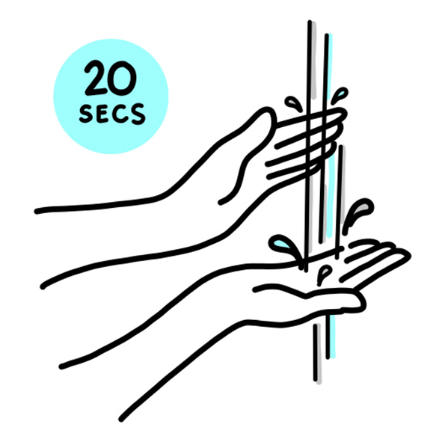 | Wash your hands before putting on the mask.
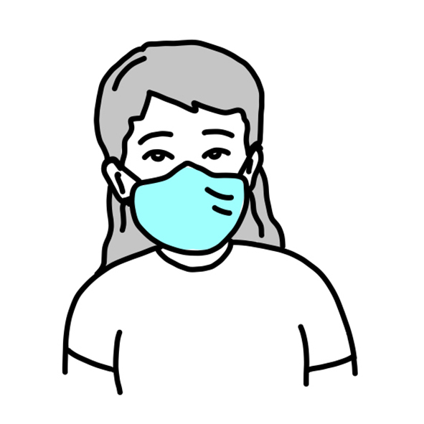 | Make sure it covers your nose and mouth and fits snugly under your chin, over the bridge of your nose and against the sides of your face.
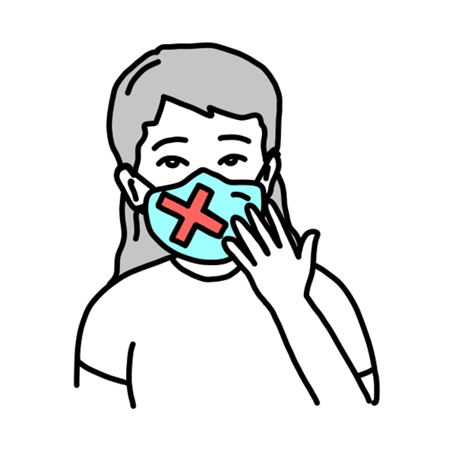 | Do not touch the front of the mask while wearing it.  If you do touch the mask, wash or sanitise your hands immediately.  Do not allow the mask to hang around your neck.
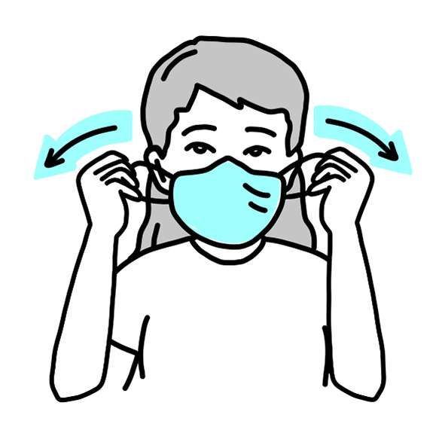 | To remove the mask wash or sanitise your hands first.  Carefully remove your mask by grasping the ear loops or untying the ties. For masks with a pair of ties, unfasten the bottom one first, then the top one.  If your mask has filters, remove them and throw them away.  Fold the mask and put it directly into the laundry or into a disposable or washable bag for laundering. Single use surgical masks should be disposed of responsibly.
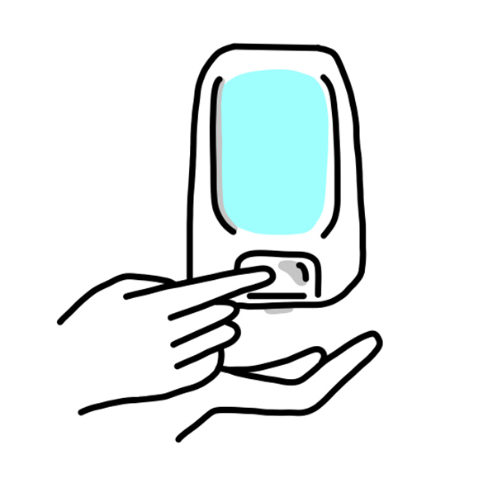 | Wash or sanitise your hands after removing the mask.

What you need to keep doing
- Wash your hands regularly
- Keep 1.5 metres from others
- Get tested, even if you have mild symptoms
- Stay home if you’re feeling unwell.

