Safe Work Instruction – Workplace Safety
Note: This Safe Work Instruction provides guidance information only and may not necessarily cover all possible hazards and should be used in conjunction with other references. |  | 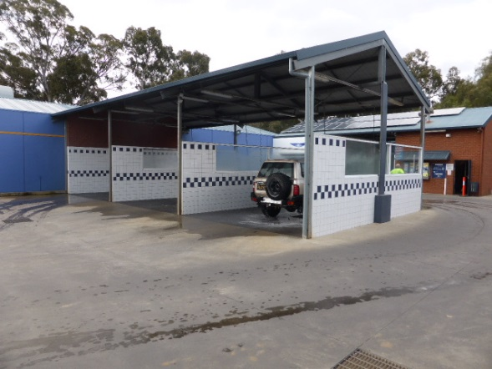

General Workplace Safety
- Keep your work area clean and tidy at all times
- Ensure there is adequate lighting for the work task you are performing
- Wear high visibility clothing/vest to ensure you are always conspicuous
- Wear non-slip shoes to prevent slips
- At all times use the appropriate PPE for the work task and regularly check that it is clean and in good condition eg. hearing protection for the plant room and safety glasses and chemical gloves when mixing or decanting chemicals
- Do not distract the attention of another worker when that person is operating equipment or involved in a work task
- Never indulge in ‘horseplay’
- If applicable, keep radio or other distracting noise at a level to ensure you can clearly hear verbal instructions, approaching vehicles etc
- Never listen to music with a portable radio or device eg iPod with ear phones
- Always comply with the Safe Work Instructions for the use of tools and/or equipment and work processes
- Only use tools and machines for their intended purpose
- Tag out and report all damaged equipment to ensure it is not used until repaired
- Never run or rush in any of the work areas. Approach blind corners with caution eg. ends of petitions or buildings
- Where possible, avoid laying electrical extension leads and hoses across pedestrian walkways
- Where possible, use equipment eg power tools, in an isolated area away from other work activities and pedestrian and vehicle movement
- Always remain in a safe area if hazardous equipment/machinery is being used
- When working in vehicle traffic areas, always remain aware of moving vehicles. Position yourself in a safe area as required. Whenever possible, carry out your work facing oncoming traffic
- If there is the need to work in a busy location or pedestrian walkway, use physical barriers eg. mesh fence, bollards and chains, witch’s hats, to guide others around your work area
- Always cease your work task if an unauthorized person enters your work area
- If working together with another worker(s), take time to plan the work process and always communicate closely to ensure procedures are adhered to and that you are aware of each other’s movements and activities
- If working on hazardous or dangerous equipment, ensure it is isolated or locked out prior to beginning works. Person that locks out/isolates the equipment should retain the key to prevent another worker from starting it up
- If working on pressurised equipment, always relieve the pressure prior to beginning works
- Report all hazards, unsafe conditions and work practices to management
- Keep your work area clean and tidy at all times

Removing Rubbish/Sharps
- NEVER place your hand/arm into a rubbish bin to remove the rubbish
- Always pull the bin liner out of the bin to remove rubbish from bins
- Hold the bin liner at the top and away from the body until placed into skip or rubbish receptacle for removal
- If there is a need to handle/remove a needle/syringe, always have on hand the sharps container
- Always use protective gloves when handling needles and syringes
- Place the needle/syringe into the sharps container. Never try to recap an uncapped needle
- Seek assistance with heavy bags of rubbish

Needle Stick Injury
- Flush the injured area with flowing water
- Wash the wound well with soap and water.
- Put antiseptic on the wound and cover it with a waterproof bandage
- Seek medical attention for an assessment of the risk and appropriate treatment
- If able to identify and retrieve the sharp responsible for the injury without any further risk of injury, take it with you in the container to your medical appointment

Avoiding Contamination
- Always have cuts and scratches properly
- Avoid standing in spray drift
- Always put on appropriate PPE prior to cleaning/washing
- Always thoroughly wash hands after working with chemicals
I have read and understand all the above information and agree to abide by all instructions
Name | Signature |  | Date

