Safe Work Instruction – Working at Heights
Note: This Safe Work Instruction provides guidance information only and may not necessarily cover all possible hazards and should be used in conjunction with other references. |  | 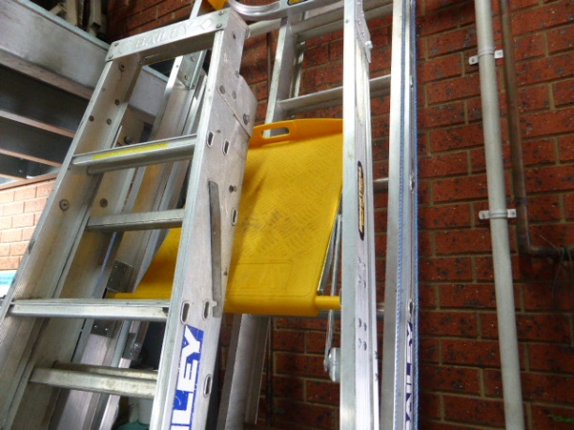

Preparation
- Only use ladders for simple access jobs, or for a short duration. It’s best to work from ground level whenever possible.
- You should also consider alternatives to a ladder, such as scaffolding or an elevated work platform. NB. Only use equipment that you have required tickets and licences for.
- Use a platform step ladder if work is required to be done from the ladder eg. replacing seals on the overhead boom, replacing lights
- Always select the appropriate ladder for the work to be performed. Do not use a metal ladder for electrical work
- Always inspect ladder for loose or damaged rungs, steps, rails and braces
- Only use a ladder if you are confident and physically-capable of doing so
- Always inspect the areas on the ground around where you will gain access to heights. Ensure surface is sufficiently level, firm and not slippery to allow safe access (eg. with ladders, scissor lift)
- Clear away from the fall zone any obstructions or objects that may be hazardous and injury a worker in case of a fall
- Avoid gaining access to heights in areas where there are hazardous fixed objects in the fall zone eg. stakes, posts, equipment
- If necessary, barricade or isolate an area beneath your work area to prevent people entering the fall zone
- Barricade off the area to ensure vehicles or people move into the area. Use a spotter if necessary.
- Familiarise yourself with the location of any power lines prior to accessing heights
- Always have a thorough inspection of all equipment to be used eg. ladder, harnesses, lanyards, hooks etc
- Appropriate rubber soled footwear (non-slip) should be worn
- If necessary, advise workers in the immediate area
- Make sure lighting is sufficient in immediate work area

Ladder Safety
- Only use tools from ladders that are designed to be operated single handed.
- NEVER use ladders during strong winds or storms except in emergencies, and then only when they are securely anchored
- Only take small items up or down a ladder – never large, awkward or heavy items. Only carry items that allow you to maintain three points of contact.
- Carry tools and materials in a tool belt or have them passed to you
- Unless a ladder is designed for additional weight, only one person should be on the ladder
- Go up and down a ladder facing the ladder, taking only one step at a time. Hold the stiles with both hands. Always maintain at least 3 points of contact when working from a ladder
- Never stand on the top two rungs of a ladder
- NEVER over-reach upwards or sideways when working on ladders. Keep your body centred between the rails
- Prior to ascending ladder, check all rungs, steps and soles of shoes are free of any slippery material
- Ensure ladder is fitted with slip resistant feet that are in good order

Using a Step Ladder
- When using a stepladder, make certain it is fully open with the spreader in good condition and securely locked. Do not use a ladder if the spreader is missing, loose or damaged.
- Check stability. Ensure that all ladder feet are on a firm, level and non-slippery surface.
- Keep the stepladder close to the work
- Place a stepladder at right angles to the work, with either the front or back of the steps facing the work.
- Never straddle the top of a step ladder
- Never stand or sit on the top cap. They are not designed to be used as a step/seat.

Using an Extension or Straight Ladder
- Make sure that the locking device is fully secured on extension ladder before use
- If there is a risk that the ladder may slip at the bottom, use another worker to brace the ladder or implement use of a prop to support the ladder
- Use the "4 to 1" rule with straight ladders. This simply means that the ladder should be placed 1 metre away from the base for every 4 metre in height to the place where the top of the ladder rests
- A straight ladder should be long enough for the job with both top railings resting on firm support
- A straight ladder should be long enough to project at least 1 metre above the level of the point of support if being used for access eg. roofs
- Where possible, extension ladders should be firmly secured or anchored at the top before performing any work eg. ladder anchor
 | Signature |  | Date

