Safe Work Instruction – Working in Wash Bays
Note: This Safe Work Instruction provides guidance information only and may not necessarily cover all possible hazards and should be used in conjunction with other references. |  | 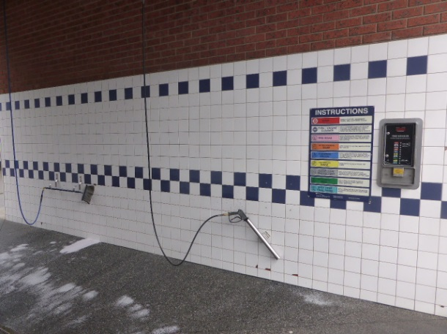

Preparation
- Set up an exclusion zone by cordoning off both ends of the bay with witch’s hats, bollards and chains other suitable barrier to prevent vehicles from entering your work area
- If using power cords or hoses, ensure they are kept well away from other wash bays and walkways and does not pose a trip hazard to others using the facility
- Never set up or run a power cord across sharp edges
- If using electric power tools, keep them clear of moisture and wet areas. Where possible, use cordless power tools
- Where possible, choose a quiet time (when vehicle traffic is light) for cleaning and maintenance to minimise disruptions to your work
- Always stop work if unauthorised people or customers come into your work area. Take them out of the work area to talk to or help them.

Cleaning Pits
- Ensure those not involved in the work task remain clear of the work area
- Always seek assistance from another worker when removing/replacing heavy grates from pits. Always use a lifting tool to loosen and lift the grate
- Shoveling from the pit may require an awkward posture. Take regular breaks during this process
- Be aware you have an uncovered pit throughout cleaning. Remain as clear of pit as possible until the grate is replaced and the pit is covered.
- Replace grate over pit as soon as possible
- Place witch’s hats or a suitable barrier around pit if it is to be left open for a period of time

Cleaning Walls
- Cleaning tiles and walls of bays may require the use of harsh chemicals. Always adhere to the safety recommendations on the MSDS in relation to the chemicals used during cleaning. Use any required PPE eg masks, gloves, safety glasses
- Pressure spraying will cause the chemicals to aerosol so it is important to protect exposed skin, the eyes and mouth and nose
- Ensure others are kept a safe distance away during the cleaning to avoid contact with any spray drift
- Avoid using these chemicals on windy days where the spray may drift lengthy distances or to other areas of the wash that may be in use

Maintenance Work
- Remember you are working in a wet area. Exercise caution if using electricity.
- If using a ladder to access the work area, take extra care to ensure you don’t slip on ladder rungs
- Ensure the ladder is positioned correctly and stable to prevent it slipping
- Ensure all hazards are removed before leaving area
I have read and understand all the above information and agree to abide by all instructions
Name | Signature |  | Date

