Safe Work Instruction – Trailer Safety
Note: This Safe Work Instruction provides guidance information only and may not necessarily cover all possible hazards and should be used in conjunction with other references. |  | 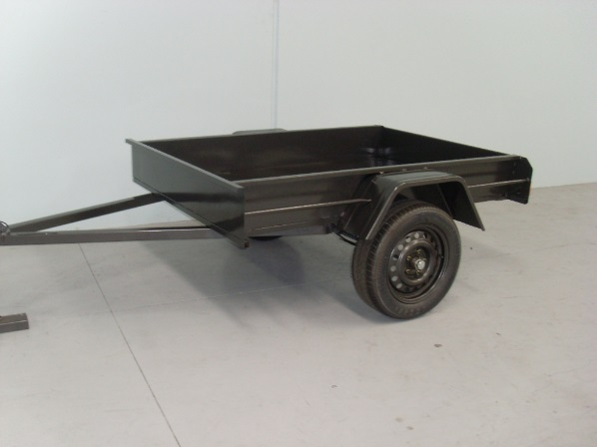

Connecting a Trailer
- Check trailer and wheels are in safe condition and tyres are correctly inflated
- Perform a visual check to ensure no people are between the trailer and towing vehicle
- Reverse with caution at a slow speed
- Check alignment and height in preparation for connection. Align ball pull with coupling on A frame of the trailer. If necessary, use jockey wheel to adjust height of trailer pull.
- Slowly reverse vehicle until ball and coupling are closely aligned. Use park brake to secure vehicle in position. Seek assistance when precisely aligning ball and coupling, particularly if jockey wheel is difficult to manoeuvre. If necessary adjust wheel chocks to allow sufficient movement
- Use jockey wheel to lower coupling onto ball. Keep hands clear as coupling connects with ball
- Ensure ball, coupling and safety chains are secured including safety latch
- Connect electric system and brakes if applicable. Complete a visual check that lights are functioning correctly.

Loading a Trailer
- Spread the load evenly across the floor or deck of the trailer and keep it as low as possible to contain the centre of gravity
- If the load is smaller than the trailer, move it as far to the front of the trailer as possible
- Avoid loads that stick out wider than the trailer and tow vehicle
- Avoid loads that are much longer than the trailer as this could impact your car’s handling. Long or high heavy loads could make the trailer sway uncontrollably
- Spread the load evenly across the floor or deck of the trailer and keep it as low as possible to contain the centre of gravity
- Do Not carry loads that exceed the trailer’s load carrying capacity

Towing with a Trailer
- Notice how the trailer affects your car’s handling and allow longer distances for braking, overtaking and joining a traffic stream and slow down before turning or entering curves
- If the trailer is bigger than normal, allow for its tendency to ‘cut-in’ on corners and curves
- Brake and accelerate smoothly and allow the trailer to move with your car
- If the trailer starts swaying, don’t brake. Hold your steering straight and progressively take your foot off the accelerator to slow gradually
- Use a lower gear on downhill sections of road, even in an automatic, so you’re not sitting on the brakes under load

Disconnecting a Trailer
- Position trailer in preparation to unhook. Take care if reversing to ensure no people are behind vehicle and trailer
- Position trailer in a suitable area. Ensure the ground is flat or level to prevent trailer from moving. Use wheel chocks when necessary
- Release safety latch and chains in preparation for uncoupling
- Wind down jockey wheel to take the weight of the trailer. Continue winding until coupling lifts clear of ball. Be aware trailer may move during this process
- Disconnect electric systems and brakes if appropriate
- All equipment including couplings, wheels, tyres, hydraulic and electric systems should be periodically serviced and inspected for safety
I have read and understand all the above information and agree to abide by all instructions
Name | Signature |  | Date

