Safe Work Instruction – Robbery and Violence
Note: This Safe Work Instruction provides guidance information only and may not necessarily cover all possible hazards and should be used in conjunction with other references. |  | 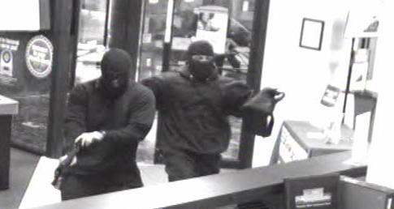

Responding to Robbery or Violence
- Always follow instructions – do exactly what the offender says
- Stay calm and quiet
- Avoid prolonged eye contact
- Do not make sudden movements
- Never argue or yell back at a potential offender
- Try to keep your hands visible throughout the ordeal
- Always advise the offender if you are going to move
- Do not attack the offender
- If it is safe to do so, take mental notes of the offender’s features eg. height, hair and eye colour, physical condition, special marks or tattoos
- Never stare at a person. Prolonged eye contact may be perceived as a challenge or threat
- If under direct threat or abuse, remove yourself from the situation and seek out your manager or supervisor
- Do not chase the offender
- If you have been subjected to a robbery or violent act and are no longer under threat, write down or record all details while they are fresh in your mind
- Monitor cash levels throughout your shift. Advise your manager or supervisor if cash levels are becoming excessive
- Don’t be predictable. Collect and count cash at varying times during the day or week
- Try to handle money at known quiet times when few others are around
- Count money in the most secure location at your work and away from public view
- Be aware of anyone who appears to be loitering in or around the wash. If they do not leave and you are certain they are suspicious, alert your supervisor or call the police
- Park as close to the car wash as possible when arriving at work if you arrive or will be leaving in the dark
- If leaving work in the dark, try to leave with other workers in groups or pairs
I have read and understand all the above information and agree to abide by all instructions
Name | Signature |  | Date

