Safe Work Instruction – Power Tools
Note: This Safe Work Instruction provides guidance information only and may not necessarily cover all possible hazards and should be used in conjunction with other references. |  | 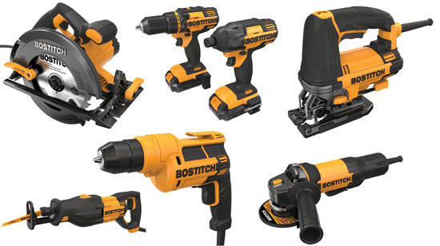

Preparation
- Inspect the tool for frayed cords, loose or broken switches, and other obvious problems. Tools that fail this inspection must not be used
- Check that any guarding is securely in place and functional
- When necessary, wear appropriate gloves, footwear, dust mask and eye and ear protection while using tool.
- Do not wear loose clothing or jewellery that may become entangled when operating tools. Tie long hair back
- Where possible, use battery operated tools in wet areas
- If applicable, ensure you are familiar with the location of the on/off and emergency stop buttons and that they are working correctly
- Work areas should have adequate lighting and be free of clutter
- Ensure observers remain a safe distance away from the work area
- Always stand firmly on the floor/ground and avoid any awkward postures that may cause over balancing
- Make sure immediate work area is clear of other tools, off cut materials or shavings that have the potential to be slipping and tripping hazards

Operating Power Tools
- Avoid accidental starting. Do not hold a finger on the switch button while carrying a plugged-in tool
- Ensure power cords are well clear of the main works area to prevent accidental contact during work process
- Allow the tool to obtain maximum speed before beginning task
- Do not place any body parts, particularly your hands near any moving parts of the tool during operation
- Never leave the power tool running unattended
- Never use power tools around flammable liquids and gases
- Always remain aware of any unusual movements, unusual sounds or other changes during operation. Cease operation if deemed to be faulty or hazardous
- Ensure power tools are sufficiently cooled prior to any maintenance
- Disconnect power tools from the power outlet while servicing or storing
- Do not wrap the cord around the tool for storage to avoid damaging the lead
- Store tools in a dry place
I have read and understand all the above information and agree to abide by all instructions
Name | Signature |  | Date

