Safe Work Instruction – Manual Handling
Note: This Safe Work Instruction provides guidance information only and may not necessarily cover all possible hazards and should be used in conjunction with other references. |  | 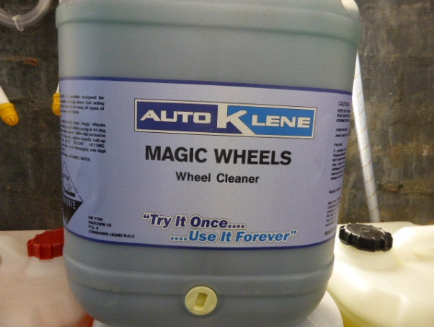

Preparation
- Manual handling is any task involving lifting, lowering, pushing, pulling, carrying or in any other way moving, holding or restraining an object. NB. Not all manual handling tasks are hazardous
- NEVER undertake any manual handling operation which is beyond your capabilities.
- Stretch your arms and legs and warm up if carrying out manual handling tasks especially in cold weather or if you have been sitting or stationary for a period of time eg. at the start of the day or after breaks.

Carrying Out Manual Handling Tasks
- Carefully test and inspect the load. Always seek assistance from other workers if in doubt as to your ability to lift, pull, lower, push, drag or carry an object.
- Plan the lift and ensure likely route is unobstructed. Remove any tools, hoses and cords that may be on the floor that are in your path of travel.
- Always use mechanical aids that have been provided for awkward or difficult manual handling tasks (eg trolleys)
- Stand as close to the object as you can
- Bend the knees and keep the back as straight as possible
- Use your leg and buttock muscles when lifting to reduce the strain on your back
- Hold the object as close to the body as you can. Try to keep the centre of the weight no more than 20 centimetres from your body
- Never twist your body during a lift. Turn using your feet, not the torso
- Never lift and/or carry an unbalanced load
- Avoid lifting heavy objects directly following a sustained period of sitting or resting
- Avoid lifting when your feet are too close together. Try to keep your feet spread to at least shoulder width
- Never stand on an unstable surface that may cause you to slip, trip and/or fall
- Plan with others to have objects that will need lifting later, to be placed or stored at a suitable height
- Where possible, break the load into smaller parts
- If involved in a repetitive task take regular breaks and, perform exercises to relieve muscle tension
- If involved in repetitive tasks for extended periods, swap or rotate jobs to avoid repetitive strain injuries
- Seek assistance when pushing or pulling heavy or hard to move trolleys, particularly over rough surfaces or up a gradient
- Exercise extra caution during adverse weather conditions (eg wet or hot weather). This can lead to slips and falls or fatigue
I have read and understand all the above information and agree to abide by all instructions
Name | Signature |  | Date

