Safe Work Instruction – Lock Out of Equipment
Note: This Safe Work Instruction provides guidance information only and may not necessarily cover all possible hazards and should be used in conjunction with other references. |  | 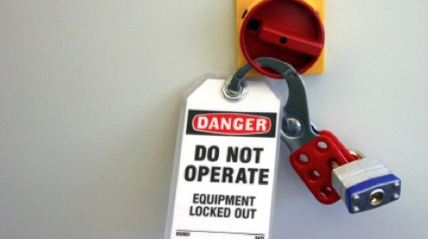

Preparation to Lockout
- Ensure ALL staff who will be affected by the lockout/tagout are aware the lockout/tagout is taking place, why and what is required of them
- Identify all parts of any systems that need to be shut down or isolated for servicing, cleaning, maintenance, installation or access
- Locate the switches, valves or other devices that need to be locked out
- Block or brace parts that could fall because of gravity
- Block parts in hydraulic and pneumatic systems that could move from loss of pressure
- Block other moveable parts

Simple Lockout Process
- ONLY use this process for simple equipment to perform checks or carry out short term simple cleaning tasks. DO NOT use this process for complex equipment or when carrying out more complex tasks.
- Ensure other staff know equipment is to be locked out and what tasks are being undertaken
- Turnoff all power, air, water and other energy sources or pressurised systems
- Place locks or tags on all control points eg. switches, taps.
- Carry out task
- Alert staff that lockout is to be removed and ensure area is clear
- Turn on power, air, water and other energy sources or pressurised systems
- Check equipment for safe operation

Lockout of equipment
- Isolate all energy sources (main and secondary) to equipment
- Disconnect electricity and turn power off at the switchboard. Allow time for electrical charges to dissipate from equipment
- Turn off compressed air valves
- Bleed any compressed air and pressurised water in lines and disconnect hoses
- Place appropriate lock out/tag out devices on all power sources, controls and valves to prevent switching on
- Remove keys or other removable controls and place in the possession of the works supervisor or the person completing the work
- Inspect the system to ensure all parts have stopped moving and are secure
- Allow all stored energy eg. electrical, hydraulic, pneumatic, pressurised water, etc. to be released or allowed to dissipate prior to commencing work
- Release the tension on any springs, or block the movement of any spring-driven parts
- Lower suspended parts to rest position
- Allow equipment to cool to avoid contact with hot equipment
- Verify all equipment is isolated
- Press all start buttons and other activating controls on the equipment itself to ensure the power doesn't go on
- Shut off all machine controls when the testing is finished
- Avoid doing anything that could re-activate the equipment

Restart of Equipment
- Notify everyone who works in the area that lockout/tagout is being removed
- Ensure workers are a safe distance away while restoring energy
- Reinstall any machine guards that were removed
- Remove any machine blocks or bracing that was placed to prevent movement
- Re-tension springs if tension was previously released
- Remove tools from the work area
- Reconnect all power sources
- Remove all lock out / tag out devices
- Turn on all power sources and test machine operation

The Golden Rules of Lock Out
Golden Rules
- Never operate a machine that has been tagged
- Never rely solely on engineering safety features
- Never remove a lock without authorization
I have read and understand all the above information and agree to abide by all instructions
Name | Signature |  | Date

