Safe Work Instruction – Fire Extinguisher Use
Note: This Safe Work Instruction provides guidance information only and may not necessarily cover all possible hazards and should be used in conjunction with other references. |  | 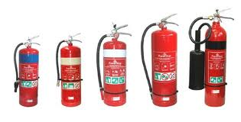

Preparation
- Familiarise yourself with the different types of fire extinguishers at the car wash
- Ensure you take the time to understand which extinguishers are suitable for different types of fires. It is also important you identify which extinguishers can’t be used on certain fires. eg. Electrical fires
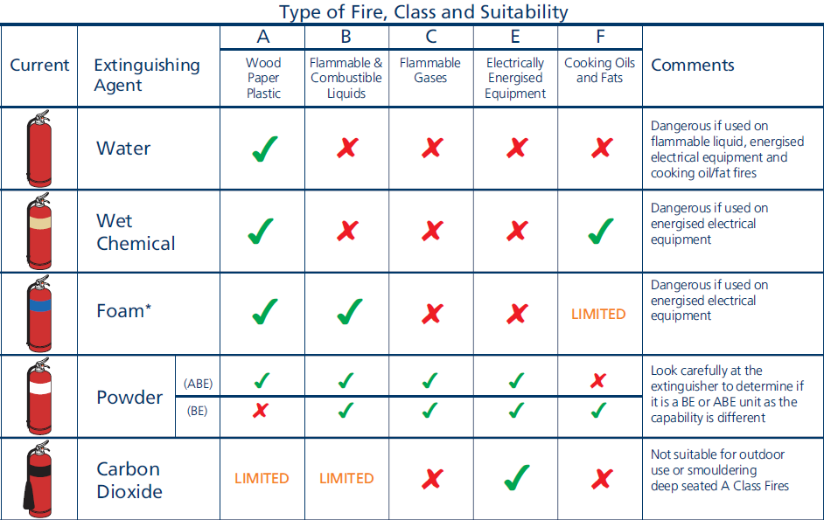
- As a general rule, for most fires likely to occur in a car wash, an ABE fire extinguisher with the white band is the best option to use
- Familiarise yourself with the operation of all fire extinguishers including pin removal and handle operation
- Be aware of the locations of all the fire extinguishers at the car wash

In the case of fire, CALL the FIRE BRIGADE - 000

Selecting a Fire Extinguisher
- Try to determine the type of material that has caused the fire or the type of material burning eg. electrical equipment, fuel.
- Select the appropriate fire extinguisher for the type of fire
- If in doubt as to the cause of the fire, use the ABE Powder extinguisher with the white band. It is suitable for almost all fires
- NEVER use a water extinguisher on an electrical or flammable liquid fire
- If you have a choice of extinguisher size, be sure to select an extinguisher of sufficient volume to complete the task

Extinguishing the Fire
- Do not attempt to extinguish a fire that is clearly too large for the equipment at the car wash. ALWAYS call the Fire Brigade - 000
- DO NOT enter areas if there is a risk of being overcome by smoke, gas or fumes
- Prior to attacking fire, release pin from handle and briefly squeeze to ensure extinguisher will operate correctly. Hold the hose firmly and direct at fire or away from people when squeezing the trigger.
- Take up a position at a safe distance that will allow you access to the base of the fire without being burnt
- Aim hose at the base of the fire and squeeze handle
- Use a sweeping motion to extinguish fire remembering to aim at base of fire. This is where the fuel is.
- Once fire is being contained move forward to complete extinguishing process
- To successfully overhaul the fire, ensure that every piece of burning material is completely extinguished
- Never position yourself in an area where you may be burnt or come in contact with falling or flying debris or hazardous materials ejected from the fire
- If fire proves more difficult to extinguish than initially thought, evacuate the area and close all doors (if applicable) to suppress the spread of the fire. Wait for the arrival of the Fire Brigade.

Maintenance of Fire Equipment
- After fire, ring your fire safety professional to replenish fire extinguisher stocks
- Use your fire safety professional to check and stamp all fire extinguishers on a six-monthly basis to ensure extinguishers are in a serviceable condition at all times.
I have read and understand all the above information and agree to abide by all instructions
Name | Signature |  | Date

