Safe Work Instruction – Electrical Safety
Note: This Safe Work Instruction provides guidance information only and may not necessarily cover all possible hazards and should be used in conjunction with other references. |  | 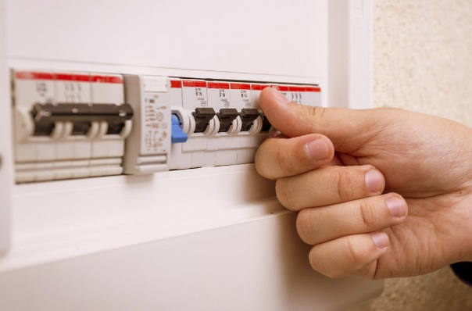
- When using electrical equipment, always check that the power cord has a current electrical test tag. Do not proceed if the next test date has expired or if there is no tag attached
- Always access power through an outlet protected by an RCD or portable RCD
- Always give the electrical equipment a thorough inspection prior to use. Do not proceed if faults or damage is detected
- Remain alert for cords that become worn or damaged. Remember they are sometimes dragged around on concrete or the ground and over sharp edges
- Regularly inspect switches on electrical equipment. Tag equipment out of use if faults are found
- If a safety switch/RCD trips during operation of any electrical equipment, always determine the cause and have it rectified prior to continuing work
- Do not use electrical equipment where it may come into contact with water
- If using power equipment outside, ensure leads and plugs cannot come into contact with water
- Where possible use battery or cordless power tools rather than mains powered tools
- Avoid having electrical cords across walkways, particularly if sharing the worksite with others
- Remain aware of the location of power cords when using electrical equipment to avoid entanglement and/or trips
- Keep power cords and leads out of the immediate work space to prevent them being damaged eg. cut, burnt.
- When unplugging cords from power outlets always turn off the power point first and grip the plug, NOT the cord
- Do Not use double adaptors as they can become partially unplugged and expose live conductors
- Do Not plug one power board into another power board as it can lead to overloading the circuit and cause a fire
- Always ensure your hands are dry whenever handling electrical equipment including switching off power points
I have read and understand all the above information and agree to abide by all instructions
Name | Signature |  | Date

