Safe Work Instruction – Computer and Work Station Use
Note: This Safe Work Instruction provides guidance information only and may not necessarily cover all possible hazards and should be used in conjunction with other references. |  | 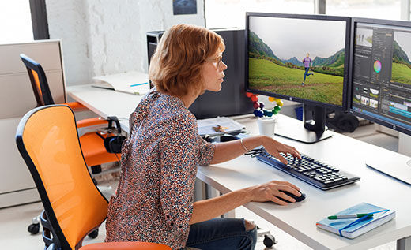

Set Up and Use
- Only fully adjustable chairs with 5 legs, adjustable height, seat pan tilt and back rest should be used for when performing workstation tasks for extended periods
- Arm rests are not recommended but if attached ensure they allow you to get as close to the desk as you require without inhibiting arm movement
- Raise or lower chair to enable the desk to be at your elbow height (touch typists may have to be seated slightly higher)
- Adjust chair so that your feet are comfortably flat on the floor with thighs approximately horizontal and clear of the front of the seat (foot rests may be required to achieve correct leg posture).
- Adjust the back rest to fit in the natural curve of your lower back
- Place keyboard as close to the front edge of the desk as is comfortable (approx. 10cm from desk edge)
- The desktop should support both arms evenly when using the keyboard
- Keep materials that are used frequently located within easy reach (a good way to arrange work materials is in a semicircle shape)
- Position mouse so that it is easy to access without stretching
- Your forearm should rest on the desk when your hand is on the mouse. It should glide over the desk when using the mouse
- The top of the screen should be at or below eye level so you can read it without bending your head or neck down or back (adjustments may need to be made for users with bifocals)
- The monitor should be located at a distance to allow you to read the screen without leaning your head, neck or body forward or backward and should be directly in front of you (not to one side)
- Always position the monitor to prevent glare on your screen. This can cause you to assume an awkward posture to clearly see information on the screen
- Place the telephone on your non-dominate side. Do not reach across your body to answer the phone
- DO NOT cradle the phone between your shoulder and your ear. Use a wireless headset if required to frequently take notes or use the computer during phone calls.

Working at the Computer
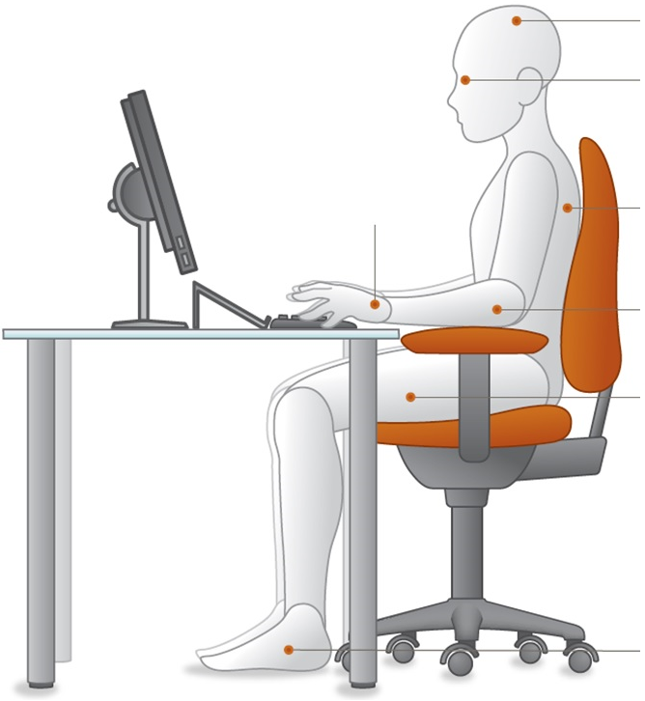
Head upright and over your shoulders.
Eyes looking slightly downward without bending from the neck.

Back should be supported by the backrest of the chair that promotes the natural curve of the lower back
Elbows bent at 90˚ with forearms horizontal. Shoulders should be in line with hips and relaxed but not slumped.

Thighs basically parallel to floor with knees slightly lower than hips. Front of seat pan does not put pressure on back of thighs or knees

Feet fully supported and flat on the floor. If this isn’t possible, then the feet should be fully supported by a footrest
Wrists are straight when resting on home keys
Max 35°

10°-15°

0°

- If working at a Laptop, ensure the laptop is raised to the correct height as detailed above and use a standard keyboard and mouse in place of the laptop keyboard and mouse.
- Ensure the floor area around and under your workstation is free of cords, boxes, files and rubbish to eliminate the need for awkward posture
Even with an ideal sitting posture, you must change your posture and position frequently by adjusting the setting on the chair and alternating tasks (typing, writing, walking and standing) as often as possible. This will ensure proper blood flow and reduce the risk of injury.

General Office Safety
- Locate ‘under desk’ drawers away from the main entry/exit path to the workstation
- Plug in electrical equipment to prevent cords laying across walkways
- Use tape or ties to confine cords and leads away from walkways and leg spaces
- Where possible, locate filing cabinets to open parallel with a wall and not into walkways or doorways
- Be aware not to overload the top drawer of filing cabinets as they may tip
- Ensure air flow from air conditioning or fans is directed away from you
- When possible, plan your day to prevent continual computer work. Vary tasks to prevent muscle stiffness/soreness
- If possible, locate printer away from the main workstation to avoid cluttering immediate area. This will also allow you to stand up and move regularly avoiding muscle stiffness and soreness
I have read and understand all the above information and agree to abide by all instructions
Name | Signature |  | Date

