Safe Work Instruction – Chemical Spills
Note: This Safe Work Instruction provides guidance information only and may not necessarily cover all possible hazards and should be used in conjunction with other references. |  | 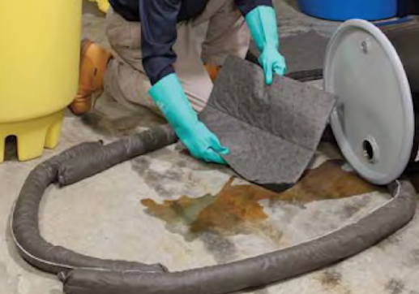

Safety Considerations
- For spills of volatile substances (eg. petrol and solvents) in confined spaces or poorly ventilated areas personnel MUST NOT ENTER. Where volatile substances are known or suspected to be involved contact the Fire Brigade for assistance
- Refer to the Safety Data Sheet (SDS) to confirm the appropriate SAFE method for containment
- If any hazardous incident or spill has created a dangerous situation staff must contact the emergency services
- Only proceed where safe to do so and use the Personal Protective Equipment that is appropriate for the task

Controlling the Spill
- If possible, control the spill at the source to limit the amount of chemical spilled. Depending on the origin of the spill, this could be done by:
  - Turning off any taps controlling the liquid
  - Tying off or blocking any burst or disconnected hoses
  - Placing punctured/split containers in bunded areas
  - Positioning punctured/spilt containers to prevent further material spilling out
  - Block the puncture or split
- If the spill has the potential for entering a waterway then the spill should be contained as a priority, before contacting others
- When controlling a spill every effort must be made to prevent the spill from entering a drainage system, water way or contaminating soil. This can be done using absorbent booms absorbent mats or absorbent pillows to control the spread of the spill.
- Establish a bund with the absorbent material to prevent the spread and absorb the spill
- If spilled substance enters a site storm water drain and a shut-off valve or other method to seal the drain is located downstream, then this valve should be closed
- Contamination of soil or waters should be avoided at all cost. Contamination accessible to the public may require a higher level of clean up within a shorter time frame

Clean up
- If a spilled substance has been contained in a section of the storm water system, or has been collected as a liquid, then the substance should be pumped out and disposed of by an EPA licensed waste contractor
- Once the leak has been controlled, the spill contained, and the threat of contamination eliminated or minimised, establish the most appropriate method for removing and disposing of the spilled substance and clean-up of the spilled substance and consumables
- Clean up should be initiated as soon as practical with no unnecessary delay
- DO NOT place oil or chemical contaminated wastes in general rubbish skips
- DO NOT hose down the spill area
- Contaminated materials (eg. spill kit materials, absorbent, contaminated soil, gloves) shall be placed into heavy duty plastic bags (double bagged if required), buckets and/or into a designated receptacle eg. bin, until an EPA licensed waste contractor can dispose of the contaminated materials or the materials can be disposed of through the appropriate local government facility.
- In all cases, employees will ensure the contaminated material is stored in a secure area where it will not contaminate soil, or be washed away by rain.
I have read and understand all the above information and agree to abide by all instructions
Name | Signature |  | Date

