Safe Work Instruction – Chemical Safety
Note: This Safe Work Instruction provides guidance information only and may not necessarily cover all possible hazards and should be used in conjunction with other references. |  | 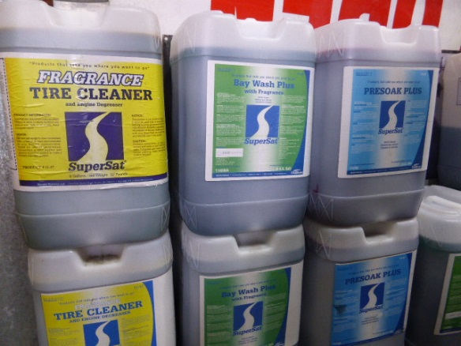

Use of Chemicals
- Ensure you have access to the Safety Data Sheets (SDS) for all chemicals used
- If you are unfamiliar with the chemical, always read the labeling and/or SDS ensuring you understand the hazards of the chemical
- Apply the recommended control measures to be used during use eg. Personal Protective Equipment (PPE), other precautions
- Always prepare and apply the chemical according to the manufacturer's instructions given on the label or MSDS taking special note of the directions for use and the safety directions
- Make sure the chemical is designed for the purpose which you are using it
- Always consider the weather conditions prior to using the chemical eg. Windy days can cause chemicals to spread and become unnecessarily airborne
- Never decant chemicals into an unsuitable eg. drink bottle or food container, or unlabelled container
- Never smoke, eat or drink during chemical use. Always wait until you have finished using the chemical and only after you have washed hands and any exposed skin areas
- Never expose flammable substances to ignition sources
- Be particularly careful when using chemicals near stormwater drains
- Use recognised spill containment methods to prevent chemical from entering stormwater drains
- Dispose of any spilled substances in compliance with EPA regulations
- Always dispose of empty containers so they pose no threat to humans, animals or wildlife
- Always store chemicals according to the manufacturer’s instructions and/or MSDS ensuring compatibility with other chemicals
- Transport chemicals in a secure, upright position to prevent any spillage
- If symptoms of illness occur during or shortly after using the chemical, depending on the severity, contact a physician or go to the hospital. Take the label or SDS from the chemical with you
- Report any chemical spills or incidents to your employer/supervisor
I have read and understand all the above information and agree to abide by all instructions
Name | Signature |  | Date

