Safe Work Instruction – Car Washing
Note: This Safe Work Instruction provides guidance information only and may not necessarily cover all possible hazards and should be used in conjunction with other references. |  | 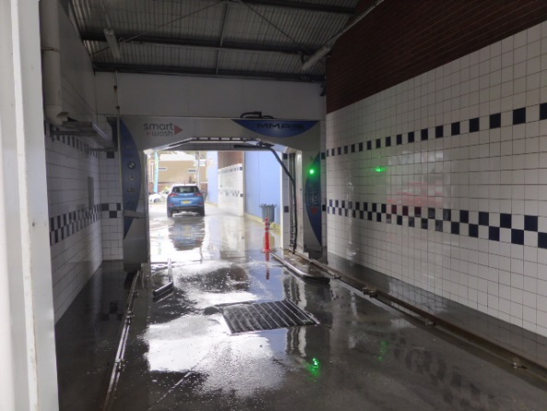

Working Around Cars
- Wear high visibility clothing/vest to ensure you are always conspicuous
- Wear non-slip shoes to prevent slips
- Make yourself aware of traffic flow and direction around the car wash
- Stand to the side of vehicles as they approach
- Avoid standing between vehicles or between vehicles and other objects
- Avoid walking in front of or between moving vehicles
- Make eye contact with the driver or alert the driver before walking in front of a car
Hand Washing
- Wear appropriate protective equipment for the chemical being used and the work being done
- Only designated drivers should drive or move vehicles in Car Wash
- Driver should be aware of the location of all workers in the immediate area when moving cars. They must ensure all workers are clear of the vehicle prior to moving vehicle.
- To avoid collisions, be aware of all other vehicle movement as you move vehicles
- Workers should stand clear of the front and rear of vehicles when they are being moved.
- Wait until vehicle is stationary, switching off with gear engaged and hand brake on before beginning wash or clean
- Ensure you have firm footing when reaching to wash the top of vehicles eg. standing on wheels to wash the roof of 4WD vehicles
- DO NOT point high pressure sprays at other people. Always have the spray pointed away from yourself when depressing the trigger.
- Keep electrical cords and equipment clear of water or wet areas
- Keep cords and hoses clear of walk areas to avoid trips
- Minimise awkward postures when cleaning cars. If necessary, change job/tasks to provide a break from awkward job/tasks
Tunnel Hand Washes
- Make yourself aware of the locations of all emergency stop buttons for the tunnel
- Wear appropriate protective equipment for the chemical being used and the work being done
- Only designated drivers should drive or move vehicles in Car Wash
- Driver should be aware of the location of all workers in the immediate area when moving cars. They must ensure all workers are clear of the vehicle prior to moving vehicle.
- To avoid collisions, be aware of all other vehicle movement as you move vehicles
- Workers should stand clear of the front and rear of vehicles when they are being moved.
- DO NOT point high pressure sprays at other people. Always have the spray pointed away from yourself when depressing the trigger.
- Keep hoses clear of walk areas
- Ensure the speed of the tunnel is at crawling speed (approx. 5 metres per minute).
- Alert other workers and ensure other workers are clear of vehicles before engaging the tunnel mechanism
- Keep at least 2.5 metres gap between vehicles when placing them on the tunnel mechanism
- Avoid standing between cars as vehicles are driven into the tunnel or as vehicles reach the end of the tunnel.
Automatic Car Washes
- Make yourself aware of the locations of all emergency stop buttons for the tunnel
- Do not enter an automatic car wash while it is operating.
- Turn off the car wash and close the entry before entering car wash.
- Allow all sprays to depressurise and mechanisms to stop moving before entering the car wash.
- If entering the car wash to respond to an urgent situation, press the emergency stop button and wait to pressure sprays and mechanism to stop before entering wash.
- If spraying pre-wash on cars prior to them entering automatic car washes, wait for the car to stop. Avoid standing directly in front of the car or between the car and other approaching cars.
- Avoid standing in the spray drift from automatic car washes
I have read and understand all the above information and agree to abide by all instructions
Name | Signature |  | Date

