Personal Protective Equipment (PPE)
PPE should only be used with other risk controls rather than being relied on as the only risk control. Select PPE to protect workers from the hazards presented by work tasks at the car wash. High visibility clothing or vests and sturdy, non-slip, covered in footwear with waterproof uppers should be worn at all times.
Recommendations for PPE use will be provided on Safety Data Sheets for hazardous chemicals. PPE should be stored to provide protection when not being used. PPE should be washed after use if contaminated and dried before use.
Eye Protection
Use safety goggles when working with chemicals and use safety glasses as protection from flying particles
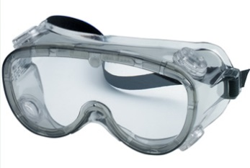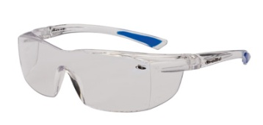
Ear Protection
Use ear plugs for controlling noise at lower levels. These can be single use ear plugs or ear plugs on a band (NB. The banded ear plugs should have the detachable plugs replaced as required). Use ear muffs for controlling louder noise levels. All ear protection should fit the wearer to ensure maximum effectiveness.
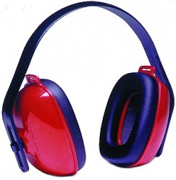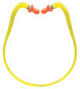
Breathing Protection
Breathing protection should be provided for dust and other airborne particles as well as for fumes and chemicals. (NB. Facial hair does not allow a proper seal and prevents the effective operation of chemical respirators).
Paper dust masks filter out larger air borne particles. Chemical respirators with filter cartridges filter out small particles and some airborne chemicals.
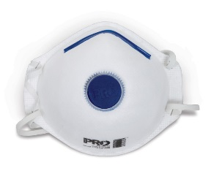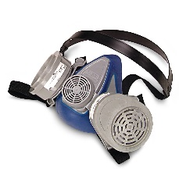
Gloves
Gloves provide protection from physical hazards that may cause cuts or other injuries as well as exposure to chemicals. Gloves should be chosen to ensure protection from the hazard present.
