For sites where only a few drums are to be stored, say less than 1200 litres, it is generally satisfactory to provide alternatives to a bund. The drums should be stored such that:
- Recovery of spilt material is possible
- They are under cover and on an impervious base
- They are away from and separated from stormwater drains and pits
- Good operational procedures are used and
- Absorbent is on hand
The design of a spill containment system should ensure the chemical in the largest container is able to be contained in an area and not released to the environment or surrounding work area. The method of containment should also separate chemicals that are not compatible and that may react if spilt eg. alkalis and acids.
What is bunding?
Bunding provides a physical barrier to prevent the release of spilt chemicals into the environment or surrounding work areas. Bunding should be able to hold at least the maximum amount of liquid likely to spill depending on the size of the chemical containers stored.
Types of bunding
- Bunding may be constructed with permanent chemical storage areas as part of the initial construction or as a retro fit. This will consist of an impervious barrier eg. concrete, plastic, which is used to construct the wall and floor of a compound and provides a barrier to retain liquid within the bunded area. It must be strong enough to contain the spill it is designed for. It must be made of a material that will not react and breakdown when in contact with the spilt chemical. It must be large enough to allow storage containers to be located to in the bunded area spilling their contents outside of the bunding if tipped.
- A chemical storage cupboard has internal bunding at it base to hold any spilt chemicals.
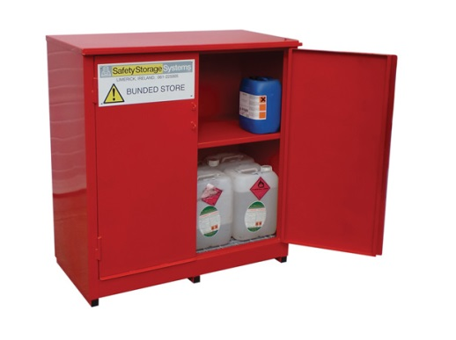
Examples of bunding
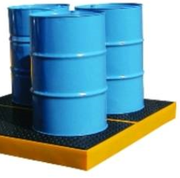
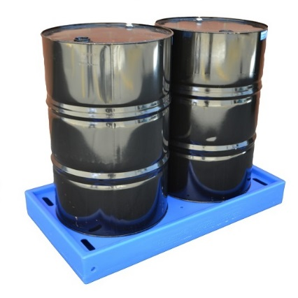

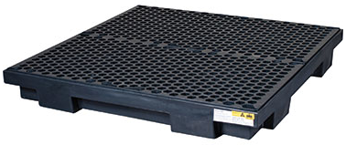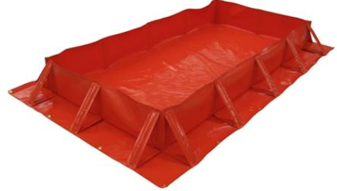

Bund requirements
Tanks
The capacity of a bunded area should be sufficient to hold at least 100% of the capacity of the largest tank plus 10% of the capacity of the second largest tank
Drums
If the material to be bunded is contained in drums (or other small containers), the bunded area should be able to contain at least 25% of the total volume of the stored products or at least 110% of the volume of the largest storage vessel (whichever is the largest volume).

Separation of Incompatible Chemicals
Chemicals that are incompatible with one another need to be separated, Incompatible chemicals may react with one other or may cause explosion or fire. Section 7 - Handling and Storage of the chemicals Safety Data Sheet will provide more information on what chemicals are incompatible with if at all. Examples of incompatible chemicals are: Alkalis and acids; and chemicals that give off oxygen and flammable liquids

Essential Equipment for Spill Containment in the event of a spill.
Equipment required will vary depending on the types and quantities of dangerous goods or hazardous substances at the car wash and may include:
- absorbent material suitable for the substances likely to be spilled
- absorbent booms, mats, pads and pillows for preventing spillage from entering drains and waterways
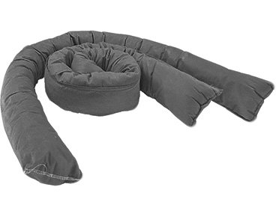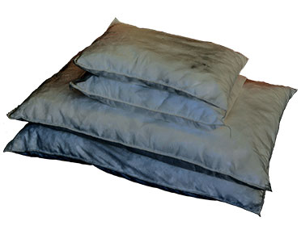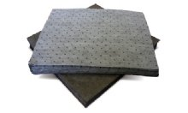
- neutralising agents for highly concentrated acidic and alkaline chemicals (eg lime or soda ash)
- suitable pumps and hoses for removal of spilled material (when large volumes are in storage)
- hand equipment (eg mops, buckets, squeegees and bins)
- heavy duty plastic bags and bucket/bin to place and dispose of spilt and contaminated material

Further Information
Information on chemicals, their storage and any compatibility issues can be obtained from your chemical supplier.

