Name of Car Wash

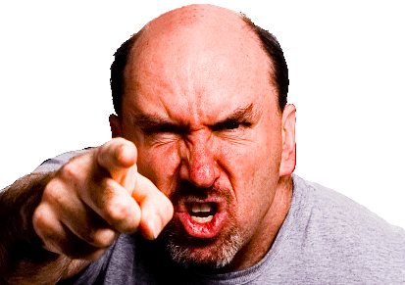

Bullying is not acceptable at our Car Wash

If you are being bullied or harassed
OR
you see someone being bullied or harassed
SPEAK UP
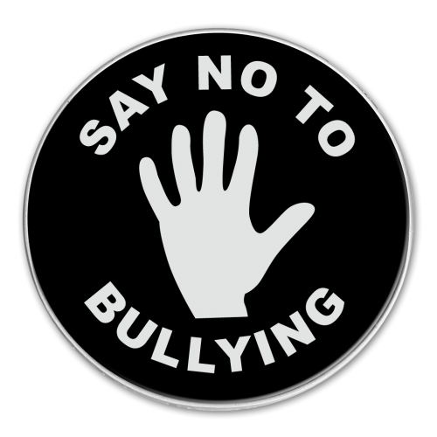
TELL SOMEONE WHO CAN HELP
NO

