Pressure vessels –
Air receivers
A Health and Safety Solution

What are the risks?
Pressure vessels can fail and explode, causing injury and death.
The Longford gas explosion in Victoria was the result of pressure vessel failure after a heat exchanger in the gas refining process broke open.
What is a solution to the problem?
Air receiver:
- inspections should be carried out by a competent person* at intervals to keep the air receiver in a safe condition (see table below).
Safety devices:
- the pressure relief valve should be overhauled and bench tested by competent persons at intervals to keep it in a safe condition

Inspection intervals
Operational surveillance and monitoring of the pressure relief valve, blowdown valve and pressure gauges should be built into standard operating procedures.
Other components:
All components of the compressed air system, such as the air receiver, air compressor, air lines/hoses and fittings, should be monitored, inspected and maintained according to the manufacturer or supplier’s recommendations.
Warning: Only use the grade of compressor oil recommended by the manufacturer.
Pressure equipment | Commissioning inspection required | First yearly inspection required | Typical inspection interval (years) |  | Typical interval for overhaul  and bench test (years)
Pressure equipment | Commissioning inspection required | First yearly inspection required | External inspection | Internal inspection | Typical interval for overhaul  and bench test (years)
Air receiver
pV ≤ 100MPa.L | No | No
pV > 100MPa.L | Yes | No | 2 years | 4 years
Pressure relief valve | Yes | Yes |  |  | 4 years
WorkSafe Victoria recommends the above inspection intervals as a minimum, subject to the condition of the plant.
Note: The Hazard Level of pressure equipment is determined by the MPa.L. This is calculated by multiplying the pressure of the vessel in Mega Pascals (MPa) by the volume (capacity) of the vessel in litres. (MPa x Litres = MPa.L)
e.g. An Air Compressor has a pressure of 0.85 MPa and of volume of 155 Litres. Multiply pressure by volume, 0.85 X 155 = 132 MPa.L (132 Mega Pascal Litres). This air compressor and air receiver would require 2 yearly external inspections and 4 yearly internal inspections.
Please note the conversion 1 cubic metre = 1,000 litres


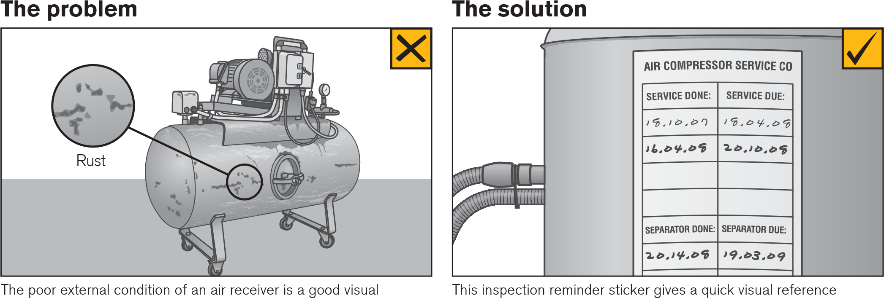
* AS 3788:2006 Pressure Equipment in Service Inspection
1.4.3 Competent person – A person who, due to their knowledge and skills, is acceptable to the owner/user/ responsible person to perform a required task. The appropriate knowledge and skills may be acquired through training, experience, qualifications or some combination of these.

This inspection reminder sticker gives a quick visual reference on the status of the inspection program. This does not substitute for inspection records.
The poor external condition of an air receiver is a good visual indicator an adequate system for operational surveillance, inspection and maintenance is not in place. An example is a build up of rust, oil and dust.

